

Contents
Legal Framework
Vision Statement
Aims
Right to withdraw
Planning, monitoring and evaluation
Inclusion and Equal Opportunities
Roles and Responsibilities
Review

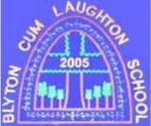

Blyton Cum Laughton Church of England Primary School
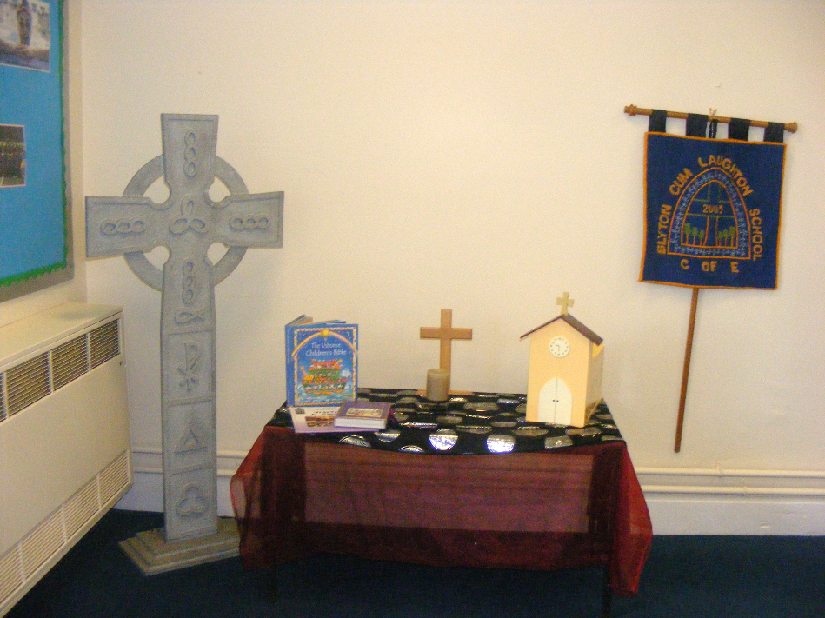
Collective Worship
Policy
Psalm 32:8 – “I will instruct you and teach you in the way you should go; I will counsel you with my loving eye on you.”
Approval Date: October 2024
Date Adapted by Governing Board: October 2024
Review Date: October 2027
Person(s) Responsible: K Duke (Headteacher) L Batey (RE and Collective Worship Lead)

What is Collective Worship?
Worship can be defined as paying homage to (revering) that which is of worth (‘Worth-ship.’). Religious Worship is the acknowledgement of ‘worth’ which is attributable to a supreme being.
Therefore, in Church of England schools, opportunities should be provided for pupils and adults to offer worship to God, through Jesus Christ. We can never make anyone worship because it is an attitude of the heart focused on God; in a school situation we should seek to lead people to the threshold of worship by providing a setting where they may worship God if they so wish.
Collective worship is therefore different both to school assembly and to corporate worship (see definitions below).
School Assembly is a gathering of the school community; it is often used to celebrate and focus on the life and values of the community itself and is without religious content.
Corporate Worship is a gathering of a body (‘corpus’) of believers and presupposes a particular religious commitment. When a school, or groups within a school, meet together for worship the activity is unlikely to be corporate worship, where the worshippers are broadly in agreement in their beliefs. Even in a school where the background of the pupils is Christian, the pupils may not regard themselves as believers.
Collective Worship is a term only used in schools. It is an act of worship that should be inclusive of everybody, invitational in nature, with an open invitation to participate. It differs in this aspect from voluntary, corporate church worship. There are no assumptions made about shared belief during collective worship, even in a church school. The 1944 Education Act requires schools ‘to provide a daily act of collective worship’ and it remains a compulsory aspect of daily school life to this day.
The Legal Requirements
We seek to comply with the School Standards and Framework Act 1998 (Section 70 and Schedule 20) which requires that:
- All registered pupils (apart from those whose parents exercise the right to withdrawal) must on each school day take part in an act of Collective Worship.
- The daily act of Collective Worship should be conducted in accordance with the provisions of the Trust Deeds of the school and the ethos statement in the Instrument of Government and should be consistent with the beliefs and practices of the Church of England.
- All acts of Collective Worship in Church schools must be ‘wholly or mainly of a broadly Christian character’.
- Pupils can be grouped in various ways for worship such as the whole school, year groups, tutor groups, classes, or other combinations.
- Acts of worship must be appropriate for all in that they should be inclusive, invitational and inspiriting take account of the pupils’ age, aptitude and family backgrounds.
- The daily act of Collective Worship will normally take place on the school premises, but all schools are able to hold their Act of Collective Worship elsewhere (e.g. the local Parish Church) on special occasions.
- Responsibility for the arrangement of Collective Worship in a Church of England school rests with the Governing Body in consultation with the headteacher.

School Vision and Aims of Collective Worship

In Blyton Cum Laughton CE Primary, worship is central to the life of our school and is a platform for exploring our vision of Psalm 32:8 – “I will instruct you and teach you in the way you should go; I will counsel you with my loving eye on you.” Worship includes an emphasis on the 6 values we have chosen: Friendship, Courage, Hope, Thankfulness, Compassion and Trust
It is well-planned and of high quality so that the whole school community is engaged on a journey of discovery, exploring the teachings of Jesus and the Bible.
For Christians in church, worship is about honouring God and responding to the loving nature of God as revealed through the Trinity: Father, Son and Holy Spirit. A school is not a church but is a collection of people who come from a variety of backgrounds for the purpose of education. The family backgrounds may be very different and collective worship must take account of the varied circumstances of adults and pupils.
However, in Blyton Cum Laughton CE Primary, the purpose of collective worship will be to invite people to a threshold where they can witness worship and join in, if they wish. Through collective worship, pupils and adults will be offered a space and a place for the telling of the Christian story. They will be offered an understanding of worship through being invited to participate in or observe prayer, reading and reflection on the Bible, liturgy, sacrament and experience of the musical and other imaginative riches of Christianity. Opportunities to reflect on the beauty, joy and pain of the world will be given. Pupils and adults will be given time to consider their responsibilities to others and to grow in love and service. Time will be given for celebration, both for the accomplishments of school members and to mark the seasonal festivals of the Christian calendar and those of other faiths. Pupils and adults will be offered time to be able to contemplate and develop spiritually. Collective worship in our school is invitational, inspirational and inclusive.

Our worship has 3 underlying principles:
- It is inclusive and contributes to the spiritual flourishing of all pupils and adults. It also contributes to the moral, social and cultural development of all pupils
- It is invitational and respects the dignity of all participants
- It is inspiring and offers a range of experiences of Christian worship

It is invitational
Acts of collective worship will:
- nurture and maintain the dignity of the image of God in everyone through working for social justice
- encourage pupils to consider the needs of others through charitable service and courageous advocacy;
- nurture reflection, stillness, meditation and prayer;
- provide pupils and adults with (age-appropriate) opportunities to explore the spiritual dimension of their lives through music, images and words.
- provide a sense of occasion that is separate from the rest of the school day;
- foster an appreciation of the natural world and our shared responsibilities for maintaining it;
- develop clear partnerships between worship in the school and the wider community.

It is inclusive
Our understanding of Christianity is that it is an inclusive faith which mirrors the attitude of Christ in the Gospels. Thus, we welcome children and adults of all faiths and none to our worship. Through their Christian character, our acts of collective worship will:
- recognise and celebrate the diversity of cultures, life styles, faiths and beliefs which exist in our school and local community;
- have an atmosphere in which everyone feels valued and safe;
- be appropriate for every student to attend;
- focus on issues and experiences which are relevant to the pupils;
- foster active roles of pupils, parents and members of the local community – in preparation, participation and leadership.

It is inspiring
Our acts of collective worship provide wider opportunities to:
- promote wide ownership of our Christian vision;
- assist learners to have increased awareness and to reflect upon fundamental issues about life;
- enhance, complement and extend curricular work;
- develop pupils’ understanding of the Christian faith and Church (Anglican) practice through appropriate Biblical and liturgical content;
- encounter and explore Jesus’ teachings and the trinitarian nature of Christian faith;
- identify opportunities for Christian celebration which can be associated with other school events;
- include appropriate references to and elements of other faiths and secular worldviews;
- include opportunities to celebrate the academic, social, personal and wider achievements of pupils.

Worship is planned in relationship to our distinctive Christian vision and our associated values. A range of people are involved in planning and leading worship, including pupils. Timetabling of acts of worship includes engagement with the local church community and various groupings of pupils. Worship is regularly evaluated by a range of members of the school community. In addition, there are a range of opportunities for worship, prayer and reflection throughout the day.
Right to Withdraw

Parents and carers have a right to withdraw their children from all or any acts of worship. In the first instance, we ask those who may wish to exercise this right to visit school to speak with the headteacher.

Inclusion and Equal Opportunities
We are committed to equality of opportunity for everyone, including those who share protected characteristics. We therefore aim to make collective worship accessible to all and accommodate individual needs when appropriate. Please see our Accessibility Plan, SEND policy and Equality Policy for further information.

Planning and organisation
- A termly overview for worship is planned each term in conjunction with SLT, Collective Worship Leader, children and local clergy.
- Collective worship is planned using the church calendar and the calendars of other faiths.
- A clear liturgy is followed for each act of collective worship.
- For each act of collective worship, a Bible reading, song and prayer are carefully planned to link with the theme of worship.
- A time of reflection is planned as part of the worship.
- Collective worship is planned in accordance with our weekly pattern of worship. Each site has 2 acts of whole key stage worship, and classroom worship led by the children, a singing worship where our pupils interpret and learn songs of praise and worship, and a whole key stage Celebration worship where the successes and achievements of or pupils are celebrated.

Monitoring and Evaluation
Our school regularly evaluates our acts of collective worship and the impact it has on the school and its wider community. Evaluation focuses on the impact collective worship has on the spiritual flourishing of pupils and adults. This involves monitoring by school leaders, staff, pupils and governors in order to grow and develop. We also welcome the contributions of parents and pupils through our suggestion boxes and questionnaires, which are reviewed and considered on a regular basis. (see attached)These are shared with staff and governors and play and integral part in developing the spiritual growth of the school. Worship is independently inspected by law under Section 48 of the Education Act 2005.

Roles and Responsibilities
The Governing Body should:
- provide a statement within the school prospectus which makes clear that the aims of collective worship within the school are based on its Christian foundation and includes parents’ legal right to withdraw their children from the act of worship;
- ensure that the school fulfills its legal responsibility for collective worship;
- in conjunction with the Headteacher, monitor and evaluate the impact of collective worship within the school and make recommendations for its development in accordance with the SIAMS Inspection Framework.

The Headteacher/Collective Worship Leader should:
- set themes for the year
- observe acts of worship led by different people as part of monitoring and evaluation processes
- develop a pupil-led monitoring and evaluation process
- facilitate pupil feedback
- regularly monitor and evaluate outcomes
- report on collective worship to the governing body
- implement collective worship development points with regard to training and resources
- annually review to feed into ongoing planning of collective worship

Pupils Leading Collective Worship should:
- have opportunities to plan and lead collective worship
- have opportunities for pupil voice in order to suggest new ideas for collective worship
- contribute to the monitoring and evaluation of collective worship in the school
- promote collective worship within the school

Visitors
Visitors should understand the educational aims of collective worship at the school and the need to avoid any proselytising. Attempts to persuade pupils to adopt a particular religious or non-religious belief are not appropriate. In general, the Headteacher is consulted before a visiting speaker is confirmed. Visitors should not speak about raising money for any particular cause(s) without the prior permission of the Headteacher.
Conclusion
Collective worship is the heartbeat of our school community and provides a range of ways for pupils and adults to flourish spiritually. If you have any questions or concerns regarding collective worship in our school, please contact the Collective Worship Lead in the first instance.

Education Reform Acts 1998 section 7(1) and the corresponding section of the Education Act 1993 Appendix BLYTON CUM LAUGHTON CE PRIMARY SCHOOL COLLECTIVE WORSHIP COUNCIL- WORSHIP EVALUATION FORM Date of conversation: ………………………………………………………………………………… Who I talked to………………………………………………………………………………………….. Class: ………………………………………………………………………………………….. What do you like about worship? What don’t you like about worship? What have you learned from our worships? What else can we do in worship?

