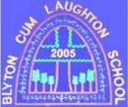

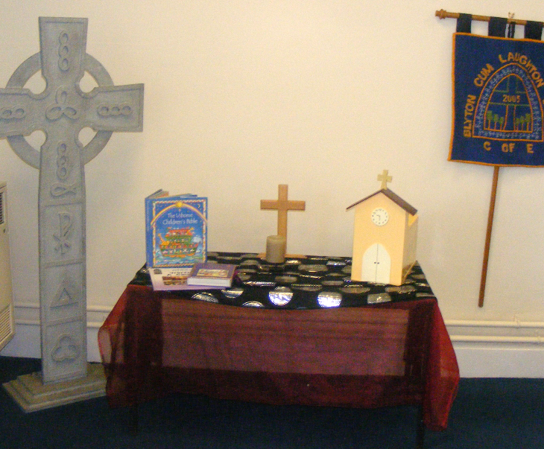

Blyton cum Laughton

Church of England Primary School

FIRST AID POLICY
Monitoring responsibility | K Duke (Headteacher)
Review date | September 2028
Head teacher’s signature
Chair of Governor’s signature
Date ratified | October 2025
FIRST AID POLICY
1. Each year a medical information sheet is sent home requesting information on allergies and medication. This is collated and distributed on both sites.
Staff administer only minor first aid and ALL STAFF have a First Aid certificate and these are renewed on a three yearly cycle in line with County Council Policy.
Specific First Aid training e.g. the use of Epi-pen is received as required.
First Aid boxes and bags are distributed around the school and regularly checked and taken out on any off-site activity.
There is a named First Aider at each site at all times.
There are always a minimum of two members of staff who have received Paediatric First Aid Training. A trained member of staff will always be at each site.

2. The Accident Books and head injury letters are kept in the offices. Head bump stickers, ice packs and First Aid kits can be found in the staff rooms.
Lists of all children who cannot have plasters and those with any allergies are kept with the First Aid kits.
CUTS
All cuts are to be cleaned using an antiseptic wipe; paper towels and cold water are not to be used. If the cut is serious a plaster may be applied if parental/guardian consent has been given. Any cuts requiring medical attention must be put in one of the Accident Books and the child taken for medical attention (preferably by a parent/guardian).
SPRAINS AND STRAINS
Sprains and strains should be elevated and an ice pack applied for no more than 10 minutes to prevent ice burns. If the sprain is serious or a fracture suspected, immobilise the limb if possible and take the child for medical attention (preferably by a parent or guardian) and report the accident in one of the Accident Books.
HEAD INJURIES
All head injuries can be potentially serious. Pupils with minor head bumps can be given a sticker and a letter is sent to parent/guardian to inform them of the injury. Serious head injuries should be reported in one of the Accident Books and the child taken for medical attention (preferably by a parent/guardian).

