

'Make your light shine so that others will see the good that you do and will praise your Father in heaven.'
Matthew 5:16

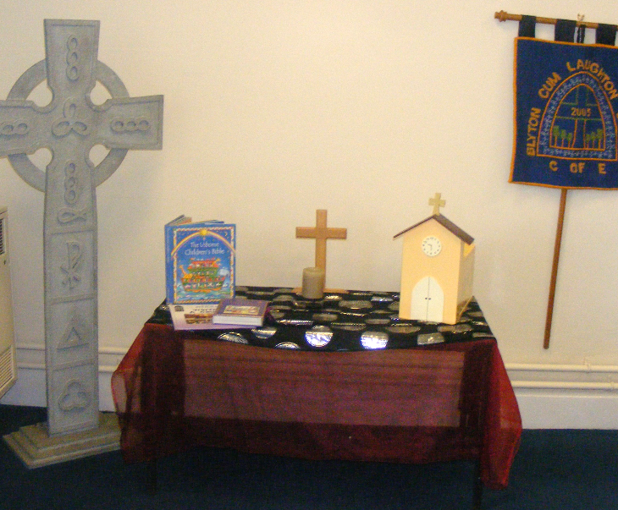

Blyton cum Laughton

Church of England Primary School

EQUALITY, DIVERSITY AND INCLUSION POLICY
Monitoring responsibility | K Duke (Headteacher)
Date ratified | October 2025
Head teacher’s signature | 
Chair of Governor’s signature
Review Date | September 2029

Overview

This policy reflects the Single Equality Act 2010 which harmonises and replaces previous legislation including the Race Relations Act 1976, Disability Discrimination Act 1995, Gender Recognition Act 2004 and Sex Discrimination Act 1975. This policy therefore supersedes all previous school policies on Disability, Ethnicity (i.e. Race) and Gender.
The Single Equality Act combines the existing three duties into one new Equality Duty that covers all seven of the equality strands: age, disability, gender, gender-identity, race, religion or belief and sexual orientation. Blyton cum Laughton Church of England Primary School will ensure that at every level, in all our work and throughout all aspects of the school’s community and its life, everyone will be treated equally.

This Single Equality Policy summarises the school’s approach in ensuring equality for all.

Objectives

- To ensure that all children have equal access to a rich, broad, balanced and relevant curriculum.
- To advance equality of opportunity by ensuing that teaching, learning and the curriculum promote equality and promote community cohesion by fostering good relations.
- To eliminate any discrimination, harassment and victimisation. To ensure that no-one is unfairly or illegally disadvantaged as a consequence of their age, disability, gender, gender identity, sexual orientation, colour, race, ethnic or nation origin, disability or religious beliefs.
- To recognise and celebrate diversity within our community whilst promoting community cohesion.
- To ensure that this Policy is applied to all the school does.
- To ensure that pupils and parents are fully involved in the provision made by Blyton cum Laughton Church of England Primary School.
- To ensure that within the school budget, adequate funding is provided to underpin this policy and that intervention, positive and preventative action is funded where necessary.

Good Practice

We aim to enhance a wider sense of community locally, as well as in the context of the UK and World communities. We support the UN Convention on the Rights of the Child, the UN Convention on the Rights of People with Disabilities and the Human Rights Act 1998. Through our policies and actions, we undertake to ensure that every child and young person is healthy, safe, is able to enjoy and achieve in their learning experience, and is able to contribute to the wider community.
We consider it prudent and sensible to maintain the practise of logging racist incidents and reporting them to the local authority. We monitor and log incidents that discriminate against children and young people of adults in our school, e.g. homophobic bullying. We also monitor and log bullying incidents, particularly those directed towards those with special educational needs.
We strive to achieve a cohesive community and expect that children respect one another and behave with respect to one another, and that their parents feel fully engaged in the school in line with our dedication to Christian values.

Strategies

- Monitoring, evaluation and review carried out by the Leadership Team will ensure that procedures and practices within Blyton cum Laughton Church of England Primary School reflect the objective of this Policy.
- Parents and Governors will be involved and consulted about the provision being offered by the school.
- Teachers will ensure that teaching and learning take account of this Policy.
- The diversity within our school and wider community will be viewed positively by all.
- Diversity will be recognised as a positive, rich resource for teaching, learning and the curriculum.
- Professional development opportunities will be provided for staff to provide them with the knowledge, skills and understanding they need to meet the requirement of this Policy.
- Contributions will be sought from parents and others to enrich teaching, learning and the curriculum.
- The positive achievements of all pupils will be celebrated and recognised.

Outcomes

This Policy will play an important part in the educational development of individual pupils.
It will ensure that all pupils are treated equally and as favourably as others.
The school will make all reasonable adjustments to promote equal opportunity and equal treatment of all members of the school community.
We are committed to meeting the individual needs of each child and will take full account of their age, disability, gender, gender-identity, race, religion or belief and sexual orientation in accordance with the requirements of The Single Equality Act 2010.

Equality Objective

The Equality Act 2010 requires schools to publish specific and measurable equality objectives. We are also committed to this expectation. Our equality objectives are based on our analysis of data and other evidence.
Our equality objective focus areas are where we have agreed to take action to improve equality and tackle disadvantages.
We will regularly review the progress we are making to meet our equality objectives.

Equality Objective 2025-2029

- Identify opportunities in the curriculum to look at other cultures/countries, study famous people from ethnic minorities and with a variety of abilities and to celebrate diversity.
- Use collective worship as an opportunity to celebrate festivals of a range of cultures and countries.
- Use events like World Cup, Olympics, WW1 centenary as an opportunity to explore other cultures.

Policy Review

This policy will be reviewed every four years by the Governing Body, as part of its monitoring cycle.

