

'Make your light shine so that others will see the good that you do and will praise your Father in heaven.'
Matthew 5:16

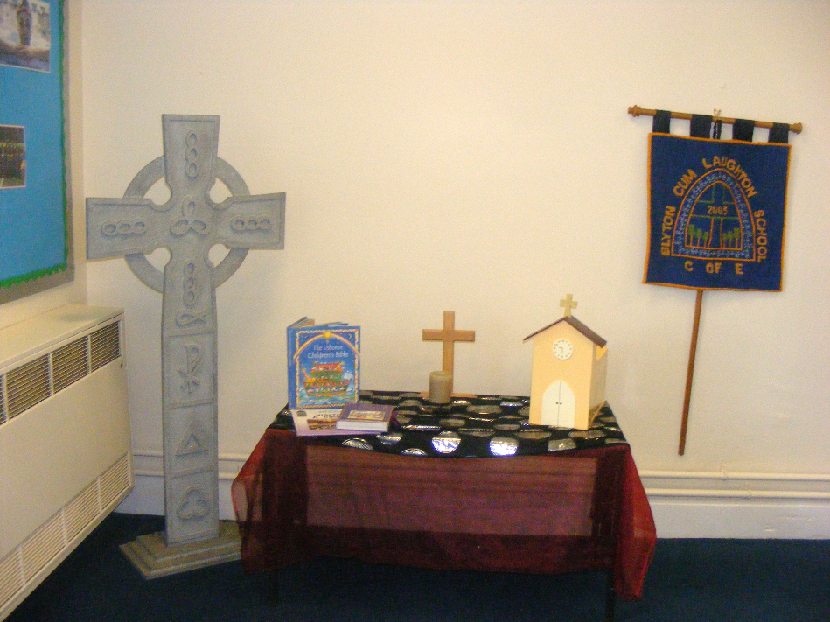

Blyton cum Laughton Church of England Primary School
Positive Behaviour Policy
Monitoring responsibility | K Duke (Headteacher)
Date ratified | Oct0ber 2025
Headteacher’s signature
Chair of Governor’s signature
Date of review | (amended Sept 2026)  October 2028

Rationale:
All children have the right to an education which offers them the best opportunities to be happy, caring and to achieve. It is a primary aim of our school that every member of the school community has a right to be valued and respected, and that each person is treated fairly, driven by our six Christian Values. We are a caring and nurturing community and our values of compassion, trust, friendship, thankfulness, courage and hope thread through every single member of that community. The school’s Positive Behaviour Policy is therefore designed to support the way in which all members of the school can live and work together in a supportive way. It promotes an environment where everyone feels happy, safe and secure, where they can be happy, caring and aim to achieve.
This policy sets out the expectations of behaviour at Blyton cum Laughton Church of England Primary School. The Governors, staff and pupils seek to maintain an environment which encourages and reinforces good behaviour and positive attitudes. It also explains the consequences should misdemeanors arise.
This policy should be read in conjunction with the school’s Anti-bullying Policy, Child Protection and Safeguarding Policy, Equal Opportunities Policy and Blyton cum Laughton’s mission statement.
Aims and Principles

We believe that the most effective way of achieving these aims is to encourage and praise positive behaviour. These are the underlying principles we wish to nurture throughout the school:

- to enable effective teaching and learning;
- to treat all members of the school community with consideration and respect;
- to value others and be polite and friendly;
- to work hard and try one’s best;
- to respect the school environment and other people’s property;
- to respect the culture and beliefs of others;
- to promote self-esteem and emotional well-being;
- to help children grow in a safe and secure environment, and to become positive, responsible and increasingly independent members of the school community.
- to ensure children know that if they are worried they can talk to any adult in the school community and receive a consistent approach

Role of the Pupil

At this age, children are still learning to socialise and develop their own opinions. Occasionally, despite all efforts, conflicts will arise. This is different to bullying. Bullying involves applying power and control consistently. (See Anti-bullying section in this policy)

Pupils are expected to:
- follow the school and classroom rules
- to reflect and accept responsibility and the consequences for their actions
- listen to and respond appropriately to what adults say

Role of Staff

It is the responsibility of all adults to implement the Positive Behaviour policy consistently throughout the school.
When a pupil behaves inappropriately, it is the responsibility of all adults to ensure that the child is heard without interruption, at the appropriate time. Adults should not act upon the information until all areas of the investigation have been explored and recorded on a Behaviour Incident Form.
It is the responsibility of staff to update the class behaviour log when a child reaches Stage 2 and consequent stages by recording the name, brief detail of incident, time of incident and stage reached.

Adults are expected to:

- create a calm, purposeful and positive atmosphere with realistic expectations
- provide a caring and effective learning environment
- encourage all pupils to achieve their full potential
- encourage positive relationships based on mutual respect
- provide a personalised learning approach to the specific behavioural needs of particular pupils, liaising with the SENDCo, Learning Mentor and outside agencies as appropriate

The school rewards good behaviour, as it believes that this will develop an ethos of kindness and co-operation. This policy is designed to promote good behaviour, rather than merely deter anti-social behaviour.

Role of Parents/Carers

Parents/Carers are expected to:

- Work collaboratively with the school, so children receive consistent messages about how to make the right choices at home and at school
- Ensure that their child fully understands the school rules and the consequences of them
- Inform the class teacher of any changes of circumstances which may affect their child’s behaviour
- Discuss any concerns with the class teacher promptly
- Support the school when the Positive Behaviour Policy is followed and sanctions given

The Role of the Headteacher
It is the responsibility of the Headteacher to:
- promote the Christian ethos of Blyton cum Laughton Church of England Primary School where all are equally valued as members of the school community
- implement the Positive Behaviour Policy consistently throughout the school, and to report to governors termly on the effectiveness of the policy. It is also the responsibility of the Headteacher to ensure the health, safety and welfare of all children and staff in the school
- support the staff by implementing the policy, by setting the standards of behaviour, and by supporting staff in the implementation of the policy
- collect data from the class behaviour logs and formulate actions on a termly basis
The Headteacher has the responsibility for giving fixed-term suspensions to individual children for serious acts of misbehaviour. For repeated or very serious acts of anti-social behaviour, the Headteacher will ensure the Lincolnshire Ladder of Behavioural Intervention is used as a structure for next steps.
The Headteacher will work closely with the SENDCo (where appropriate), Learning Mentor and outside agencies to ensure children at risk receive the best possible provision.
Role of Governors
The Governors of the school support the Headteacher and staff by:
- promoting the Christian ethos of Blyton cum Laughton Church of England Primary School where all are equally valued as members of the school community
- creating an effective partnership between pupils, parents, staff and governors
- maintaining a caring, safe and nurturing environment where pupils can flourish
- developing a positive relationship in the community
- ensuring that the school community is safeguarded
- reviewing the standards of discipline and behaviour on a regular basis
- supporting the Headteacher in carrying out the Positive Behaviour Policy effectively

Positive Behaviour Management
Positive behaviour management may be defined as the strategies the school employs to promote a well-ordered, purposeful school community. These strategies underpin the Positive Behaviour Policy.
Guidelines
Children who make consistently good choices in class and around school are rewarded for their efforts. In addition, the following may be used:
- Verbal praise
- Approving signs/acknowledgements
- Sent to another teacher/ Headteacher to share good learning
- Staff congratulate children
- Staff give children stickers for their house reward chart. Certificates and reward cards are sent home for Values related weekly awards and for achieving 10 or 20 stickers
- Celebration Worship recognises positive choices through the BcL Extraordinary Lives certificates and BcL Values badges recognise exceptional choices

Formulating class rules
At the start of the school year, each class negotiates their own class rules which are worded positively and displayed on the wall of the classroom. In this way, with constant reinforcement, every child in the school knows the standard of behaviour that we expect in our school. If there are incidents of anti-social behaviour, the class teacher discusses these with the whole class.

Blyton cum Laughton Church of England Primary School Reward System
The reward system is to encourage and acknowledge all children who follow the school’s expectations e.g. good behaviour, supporting peers and adults with daily tasks and taking responsibility to achieve their personal best.
How does the system work?
- All adults have dot stickers to award children seen to be ‘making the right choice’. Children keep the stickers on a chart in the classroom. These are also rewarded for academic success.
- When children have received 10 and 20 stickers, they can choose a postcard to be written by the Headteacher and sent home to parents.
- BcL Values Badges are handed out by members of the Junior Leadership Team in recognition of exceptional choices linked to our six Christian Values.

To maintain a consistent approach across the school please ensure the following:

- Stickers must never be taken away for inappropriate behaviour
- Children can be awarded stickers for personal success or consistently meeting the school’s expectations
- Chart continues for one ‘big’ term (3 per year)
- Stickers can be awarded by any adult to any child and by child to child to promote peer positivity
- Awarding stickers when children are least expecting it e.g. holding a door open, good manners in the dining hall, lining up is encouraged

Non-adherence to Positive Behaviour Policy – summary of procedures
These procedures assume a gradual increase or persistence in poor behaviour. If behaviour degrades very quickly or if the first incident is of a serious nature (i.e. physical aggression) then it is acceptable to skip steps e.g. child may spend time with an adult at break-time.
There may be occasions when choices would warrant Reflection Time. In this case, the child would complete their learning in another classroom.
We expect early intervention at Step 2 including parental communication and this proactive response will resolve the majority of issues. Early involvement makes it easier to develop positive partnerships between school and home.
The school employs a number of sanctions to enforce school rules, and to ensure a safe and positive learning environment. We employ each sanction appropriately to each individual situation.

 | Behaviour displayed | Steps | Break Time / Lunch Time
Warning | - Repeatedly talking while an adult is talking.  - Repeatedly shouting out.  - Low level behaviour; rocking on chairs, inattention, persistent noise making, inappropriate behaviour around school  - Rude/disrespectful  - Name calling/teasing  - Play outside which is deemed too physical/causing harm  - Swearing | - Non-verbal reminder or  - Verbal reminder of clear expectations of appropriate behaviour choice  - Praise for choosing to respond positively  - Pupils have the opportunity to seek forgiveness and reconciliation and are supported by adults to do so. | - Non-verbal reminder  - Verbal reminder of clear expectations of appropriate behaviour choice  - Praise for choosing to respond positively
Step 1 | - Repetition following warning | - 5 minutes timeout on the playground with adult  - Clear explanation given to the child of the consequences for the action  - Guidance to ensure appropriate choice next time a situation arises  - Pupils have the opportunity to seek forgiveness and reconciliation and are supported by adults to do so. | - 5 minutes timeout on the playground with adult  - Senior midday supervisor to be informed  - Class teacher informed
Step 2 | - Continued repetition or combination of listed behaviours | - Step 2 recorded in class behaviour book  - Clear explanation given to the child of the consequences for the action  - Break-time/lunch-time spent outside with an adult or in the classroom if the class teacher is staying in class  - Parental communication by class teacher discreetly at the end of school or a phone call  - Pupils have the opportunity to seek forgiveness and reconciliation and are supported by adults to do so. | - Step 2 recorded in behaviour book  - 15 minutes/break or playtime timeout with adult  - Parental communication by class teacher
Step 3 | - Further repetition or combination of listed behaviours | - Step 3 recorded in class behaviour book  - Clear explanation given to the child of the consequences for the action  - Praise for choosing to respond positively  - Child may complete Reflection Time in another classroom until the end of the session with learning provided by the class teacher  - Headteacher informed who will discuss choices with the child  - Lunchtime spent with a member of SLT  - Parental communication by class teacher  - Pupils have the opportunity to seek forgiveness and reconciliation and are supported by adults to do so. | - Additional missed break/lunch break apply  - Class teacher informed  - Step 3 recorded in behaviour book by class teacher  - Headteacher informed – will discuss choices with child
If a child reaches Step 3 on more than one occasion in a week the Headteacher should be notified again. The Headteacher will then meet with the child and the class teacher to discuss the behaviour choices.
If a pattern of Step 3 behaviours are occurring repeatedly across a number of weeks, a meeting with the child’s parent (Headteacher and class teacher) will be arranged to discuss positive steps forward.
A child who regularly reaches Step 3 will be referred to the learning mentor for regular support.

Step 4 | - Aggressive behaviour and/or violence towards children and/or adults  - Dangerous behaviour in or around school.  - Intentional harm caused by fighting, punching, kicking, strangling, marks made on skin.  - Bullying  - Racism  - Attempted absconding  - Significant damage to school property  - Discriminatory language including misogony | - Headteacher immediately informed  - Investigation completed by class teacher/Headteacher  - Judgement made following investigation over number of break/lunchtimes missed or/and Reflection Time in the Headteacher’s office or with member of SLT. (Any Reflection Time must include learning supplied by the class teacher)  - Depending on the seriousness of the offence (at the discretion of the Headteacher) a phone call will be made to the parents/carers by senior teacher/assistant headteacher or Headteacher  - A meeting with parents may be organised  - Record of Step 4 and Reflection Time to be completed in class behaviour log  - Bullying/homophobic/racial incidents are logged (Headteacher’s office) and communication made with the victim/perpetrator’s parents/carers by the Headteacher  - Learning mentor informed for potential intervention  - Pupils have the opportunity to seek forgiveness and reconciliation and are supported by adults to do so. | - Class teacher and Headteacher informed by midday supervisor  - Sanctions as listed in previous columns
It is to the Headteacher’s discretion whether the behaviours displayed require an increased sanction (e.g. 2 days without breaks)
All behaviours displayed in Step 4 should involve an investigation involving witnesses and should be led by the class teacher or Headteacher. Statements should be recorded on behaviour logs.
A meeting will be arranged with parents/carers, the Headteacher, the class teacher and the child if there are repeated Step 3 behaviour concerns or single incidents of Step 4 behaviours

A child who regularly misbehaves and who does not respond to the measures up to and including Step 4 will be referred to the SENDCo and consideration for assessment by outside agencies and will be placed on the SEND register if, after a specialist teacher report, a need is identified. In such cases, the following course of action will be followed:
- Staff co-ordinate discussion with parent/carer re: incident / behaviour concerns
- A home/school book is considered
- Headteacher, SENDCo, teacher, parent and pupil are involved in drawing a plan of action which may include a Behaviour Support Plan
- A time-scale and review date is agreed

Children at Risk of Exclusion
The school uses the guidelines published by the Local Authority and will ensure that all levels of the Lincolnshire Ladder of Behavioural Intervention are followed.
External agencies may be included and a new plan of action created:-
- BSP (Behaviour Support Plan)
- PSP (Pastoral Support Plan) A PSP is drawn up when the pupil is at risk of Fixed Term Suspension. It covers 16 school weeks and aims to improve behaviour based on small step tasks.
- Time scales and regular review dates will be agreed
The final sanction is to exclude a child from school. The school follows the Lincolnshire County Council guidelines.
- Headteacher imposes Fixed Term Suspension (following guidelines from the Local Authority)
- Headteacher imposes Permanent Exclusion (following guidelines from the Local Authority)
The main reasons for exclusion are as follows;
- Physical assault against a pupil
- Physical assault against an adult
- Verbal abuse/threatening behaviour against a child
- Verbal abuse/threatening behaviour against an adult
- Bullying
- Racist/Homophobic/Transphobic/ Abuse
- Sexual Misconduct
- Drug and alcohol related incidents
- Damage
- Theft
- Persistent disruptive behaviour
The school employs a number of sanctions to enforce school rules, and to ensure a safe and positive learning environment. We employ each sanction appropriately to each individual situation.
Anti-bullying

The school does not tolerate bullying of any kind. If we discover that an act of bullying or intimidation has taken place, we act immediately to stop any further occurrences of such behaviour. Whilst it is very difficult to eradicate bullying, we do everything in our power to ensure that all children attend school free from fear. An anti-bullying focus week is held each year when bullying is discussed and all pupils know how to deal with any issues and are aware of the consequences of unacceptable behaviour.
Bullying is defined as deliberately hurtful behaviour, repeated over a period of time, where it is difficult for those being bullied to defend themselves. The three main types of bullying are:
- Physical (hitting, kicking, theft)
- Verbal (name calling, racist remarks)
- Indirect (spreading rumours, including via social media, by excluding someone from social groups)
Schools’ teaching and support staff must be alert to signs of bullying and act promptly and firmly against it in accordance with school policy.
We encourage children to talk to someone if they are being bullied. Staff only intervene physically to restrain children or to prevent injury to a child, or if a child is in danger of hurting him/herself. The actions that we take are in line with government guidelines on the restraint of children.
Online Safety
The school recognises the need for online safety and the growing incidences of online bullying in all its forms, including texting.
The Lincolnshire Schools’ Acceptable Usage Policy and E-Safety Policy is in place and is applied to all members of the school community.
The internet, gaming and social media has become an integral part of children’s lives, enabling them to undertake research for school projects, talk to their friends and access information from around the world. Increasing provision of online activity in and out of school brings with it the need to ensure that learners are safe.
As part of our regular focus weeks on anti-bullying, we have had online safety as a theme in order to raise the children’s awareness and have introduced an Online Safety pupil group with the responsibility of sharing up to date guidance with their peers.
All staff and children receive online safety training and information from National Online Safety is sent to parents/carers regularly.
Review
The governing body reviews this policy every three years. The governors may, however, review the policy earlier than this, if the government introduces new regulations, or if the governing body receives recommendations on how the policy might be improved.

