LOCATION  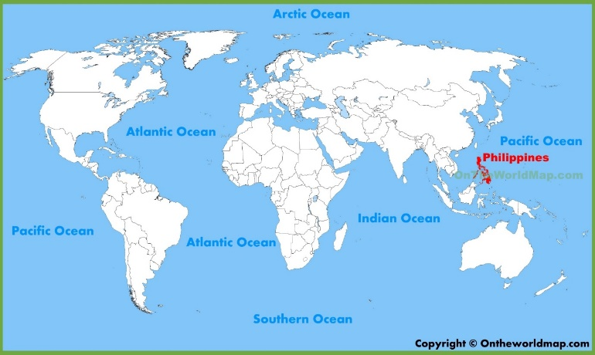  The story is set on Culion Island which is one of the 7641 islands that make up the Philippines.- this is in the continent of Asia | 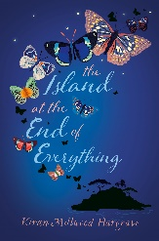  Ami lives with her sick mother on an island where the sea is as blue as the sky. It’s all she knows and loves, but the arrival of a cruel government official, Mr Zamora, changes her world forever.  It’s a story of friendship, love and family; a story which makes us consider how we treat others. | Butterflies are beautiful, flying insects with large scaly wings. Like all insects, they have  - six jointed legs,  - 3 body parts, - the head, thorax (the chest), and abdomen (the tail end).  - a pair of antennae, (feelers)  - compound eyes,(more than one unit)  - an exoskeleton. (outside covering for the body)  907 species of butterfly in the Philippines  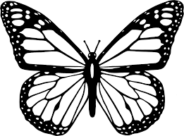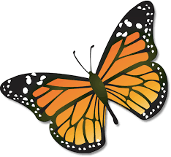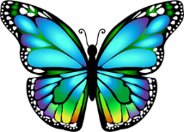
KEY FACTS  From 1906 lepers were sent to the island from the Phillipines  Leprosy is a hugely stigmatizing condition, linked to dirtiness and sin when in fact it is a bacteriological disease. It is very  hard to catch, and cannot be transmitted by touch  Leprosy was widespread for millennia throughout Asia, Africa and Europe until a cure was developed and made internationally available in the 1980s. Cases still number in the hundreds of thousands, but many of these are cured.  .  From 1906 to 1910 alone, 5,303 men, women and children were transported to Culion Island. It was the largest leper colony in the world.  It was only declared leprosy free in 2006 | VOCABULARY  Nanay -Mother  Ama -Father  Lolo -Grandfather  Gumamela -Hibiscus, a kind of flower common in the Philippines  Tadhana -Fate  Takipsilim -Twilight  Habilin -Something given to someone for safekeeping  Lihim -Secret  Diwata -Guardian spirits, usually of nature  Pitaya -Dragon fruit  Pahimakas -Last farewell  Touched -has leprosy  Untouched -does not have leprosy |  | VOCABULARY  kaleidoscope- a group of butterflies  lepidoptery/lepidopterology: the study of butterflies and moths  lepidoptera – insects which include butterflies  lepidopterist: a collector of butterflies  orphan- a child whose parents are dead  orphanage- a place for the care and education of orphans  segregation- to be separated from another thing

