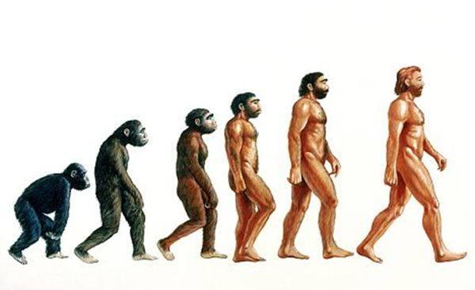

**Key Vocabulary**

**adaptation – The process of change so that an organism or species can become better suited to their environment**

**body fossil – Preserved remains of the body of the actual animal or plant itself**

**breeding – The mating and production of offspring by animals**

**environment – The surroundings or conditions in which a person, animal, or plant lives**

**evolution – The process by which different kinds of living organism are believed to have developed from earlier forms during the history of the earth**

**fossil – The remains or impression of a prehistoric plant or animal embedded in rock and preserved**

**inherit – To gain a quality, characteristic or predisposition genetically from a parent or ancestor**

**offspring – A person’s child or children/ an animal’s young**

**reproduction – The production of offspring by a sexual or asexual process**

**selective breeding – The process by which humans use animal breeding and plant breeding to develop selective characteristics by choosing particular animals and plants**

**trace fossil – Indirect evidence of life in the past such as the footprints, tracks, burrows, borings and waste left behind by animals**

**Evolution**

