**CLOVER CLASS 2023-2024**

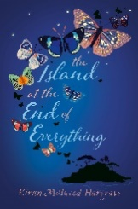**AUTUMN TERM**

**Get ready to lose yourself in a world of books!**

This term our learning takes us on a journey of discovery, exploring the world of humans and animals.

Our ‘main’ class text is **‘The Island at the End of Everything’**, by Kiran Millwood Hargrave, where we will learn about the realities faced on a leper colony in the Philippines. It will cause us to question whether segregating people was the right thing to do. We will also explore the symbolism of the butterfly within the text, visiting ‘Tropical Butterfly House in Sheffield to experience the beauty of the butterfly first-hand.

We will examine this book in whole-class reading, looking at the ways that characters are portrayed and at the kinds of vocabulary used to engage the reader.

We also look at the discoveries of Charles Darwin, John James Audubon and Rosalind Franklin though the texts:

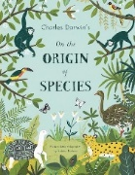  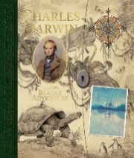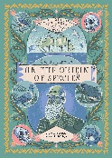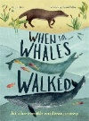

learning about adaptation and evolution. We travel with Darwin to the Galapagos Islands, looking at the features of the landscape, such as volcanoes, which have helped created environments for living things, and look at the work of one of his contemporaries, Alfred Russel Wallace.

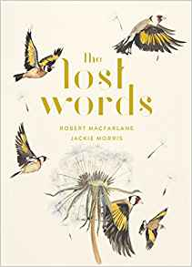Art takes its inspiration from the text: **‘The Lost Words’** and the artist **Jackie Morris**. We will explore a range of painting techniques inspired by the text, developing our skills in our sketch books.

In **RE**, we will be exploring the principles underlying **Humanism**. Our **Christian Value** this term is ‘**friendship’.** In our class collective worship, we explore the question ‘How can we be friends of the Earth?

Our music focus is for our **‘Young Voices’** concert in January. Not only do we practise our siging and dancing routines in these sessions, but we explore different music styles and the ways that the different elements of music are created. Details of how to access the music to practise at home will be sent out, and a lunchtime club is held for all Y5/6 pupils on a Friday lunchtime.

**Weekly home engagement tasks**

**Reading**

In Clover class, we read independently, but it's nice if you will let us read to you at home too- this can be recorded on our bookmark, We like to discuss what we have read, looking closely at how an author gives clues about the characters in the book. We will have a reading journey book in school where we will be recording our thoughts about the book. on

**The expectation is that we read every night** as we will be making comments about what we have read. Keeping us ‘on track’ with our reading will help our work in the classroom.

**Spelling***.*

We have a spelling log where we note spellings we are learning on. We can bring this home every day but need it in school every day for us to add to as we work. Our words may be:

1. *a particular letter string. We can use* ***Spelling Shed*** *to support us with learning these words- there will always be an assignment set using that letter pattern as well as others.*
2. *Personal words- these are words which individual pupils spell incorrectly and so need to practise further. There may be a personal list on Spelling Shed set up to practise these words further*
3. *Y3/4 and Y5/6 lists. These words are examples of the kinds of words which the government recommends that pupils should be able to spell. They are words which we are expected to use in our independent writing.*

We learn spelling in different ways so you will see us trying out different techniques such as mnemonics and  colours for letter strings. We will always use joined handwriting for our spellings and write them starting with a small letter.

**Times Tables**

We use **Times Tables Rock Stars** to practice our multiplication tables.

Multiplication tables are linked to so many area of mathematical learning such as fractions, percentages and ratio, so it is crucial we know all of our tables as well as their related division fact.

**PE** with Mr Johnson is Friday- rmeember to come in your school PE kit. Earrings are to be removed or covered with tape for safety reasons.

Please feel free to contact Mrs Batey with any queries.