THE ARRIVAL- SHAUN TAN  The Arrival tells a story of immigration through images.  The story is about a man leaving his home to find work and support his family, whose home has apparently become unsafe. In the new land, the man goes through a lengthy administrative process and manages to find a small living space. The story encourages the reader to think about what the illustrations might represent both for the man and for the world we live in. |   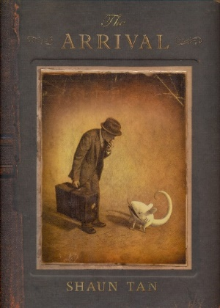  ARRIVALS and DEPARTURES | THE MATCHBOX DIARY- PAUL FLEISCHMAN  When a little girl visits her great-grandfather, she chooses an unusual object to learn about: an old cigar box. Inside she finds a collection of matchboxes making up her great-grandfather's diary, each one evoking a memory. Together they tell of his journey from Italy to a new country, America, exploring the process he had to go through at Ellis Island in order to enter the country.
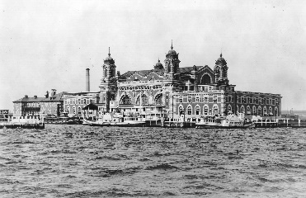  KEY FACTS  Ellis Island is an island in New York Harbour that was the United States' busiest immigrant inspection station. From 1892 to 1954, approximately 12 million immigrants were processed  sepia – a drawing or photograph in a brownish tone  Both books have sepia illustrations, like the colour of old photographs. | KEY VOCABULARY  evacuee – a person moved from a place of danger to safety  immigrant -a person who comes to live permanently in a foreign country.  immigration -the action of coming to live permanently in a foreign country.  migrant - a person who moves from one place to another, especially in order to find work or better living conditions.  migration- movement from one region to another  refugee - a person who has been forced to leave their country in order to escape war, persecution, or natural disaster. | VALUES  The books explore the relationships between the characters and the power of family ties. The values of friendship and love are woven throughout.  