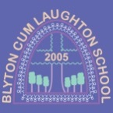

BcL: Extraordinary Lives

Throughout their journey through our curriculum, children will learn about many people from the past and present who have had a significant
impact in their chosen field. We have organised these extraordinary lives into six INSPIRATIONAL THEMES and they are all linked to our school’s
six CHRISTIAN VALUES of Trust, Courage, Thankfulness, Compassion, Hope and Friendship. Children may meet some of these key figures
repeatedly during their school journey but each time in a greater depth and in a context appropriate to their learning.

Our BcL EXTRAORDINARY LIVES categories are:

- FIGURES OF FAITH: We follow in the footsteps of their FAITH and FRIENDSHIP and will show FAITH in God and in each other through FRIENDSHIP
- LEADERS: We have TRUST in their leadership and will therefore strive to lead and for others to show TRUST in us
- EXPLORERS: We appreciate their COURAGE in adversity and will be COURAGEOUS when facing our own challenges
- INNOVATORS: We are THANKFUL for their imagination and will aim to inspire THANKFULNESS in others through our own independent thinking
- CARERS: We are inspired by their COMPASSION for others and will be COMPASSIONATE to everyone
- CREATORS: We enjoy the HOPE that their CREATIONS brings us and will provide HOPE to others through our own CREATIVITY

Our BcL INSPIRATIONAL THEMES, which thread through the BcL Curriculum are:

- DIVERSITY
- LEADERSHIP (including Monarchy and Conflict)
- EXPLORATION
- INNOVATION & PROGRESS (including the regional focus of agriculture)
- CARE AND PROTECTION (including Environmental issues)
- CREATIVITY

 | Term 1 | Term 2 | Term 3 | Term 4 | Term 5 | Term 6
Ivy (Cycle 1) | John Dunlop (Sc)  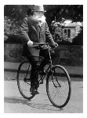  Queen Elizabeth II (H)  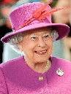  Dina Asher-Smith (PSHE)  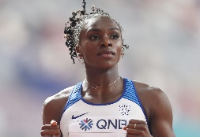 | Neil Armstrong (H)  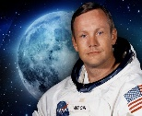  Tim Peake (H)  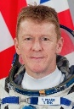 | Margaret Wilcox (Sc)  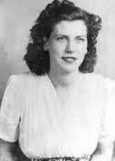  Ernest Shackleton (H)  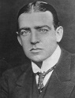 | Rachel Carson (Sc)  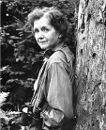  Christopher Colombus (H)  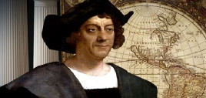 | Joseph Banks (Sc)  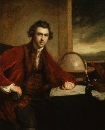  Greta Thunberg (PSHE)    Andy Goldsworthy (A)  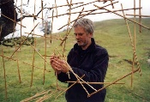 | Anna Atkins (Sc)  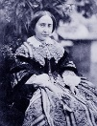  Waterhouse Hawkins (A/DT/H)  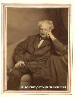  Mary Anning (H)  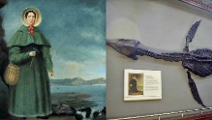  Betty Snyder, Jean Jennings & Kay McNulty  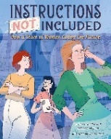
Ivy (Cycle 2) | Pr. Muhammed (RE)  Charles Macintosh (Sc)  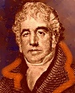  King Charles II (H)  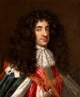  Mary Seacole (PSHE)  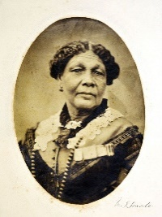 | Dian Fossey (Sc)  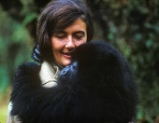  Amy Johnson (G)  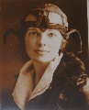  Amelia Earhart (G)  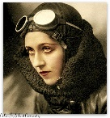  Jesus Christ (RE)  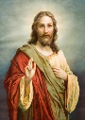 | G Nammalvar (Sc)  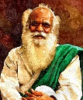  Malala Yousafzai (PSHE)  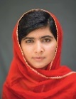 | King John (H)  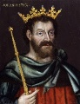  Enid Blyton (H)  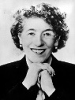  Tia Kansara (Sc)  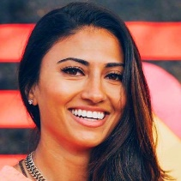  Andy Goldsworthy (A) | Charles Darwin (H/Sc)  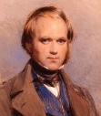  Sir David Attenborough (H)  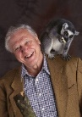 | Marie Curie (Sc)  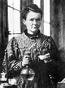  Louis Pasteur (Sc)  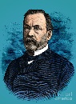  Malala Yousafzai (RE)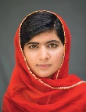  Betty Snyder, Jean Jennings & Kay McNulty
Willow (Cycle 1) | Mary Anning (Sc)  Kate Sessions (PSHE)  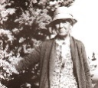  Tim Berners-Lee (C)  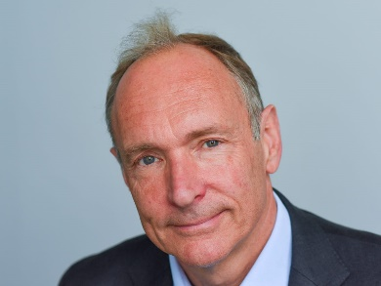 | Dmitri Ivanovich Mendeleev (Sc)  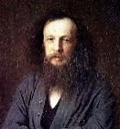  Ada Lovelace (C)  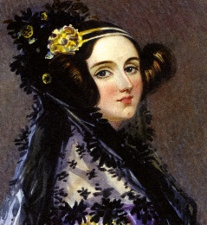 | Avicenna (Sc)  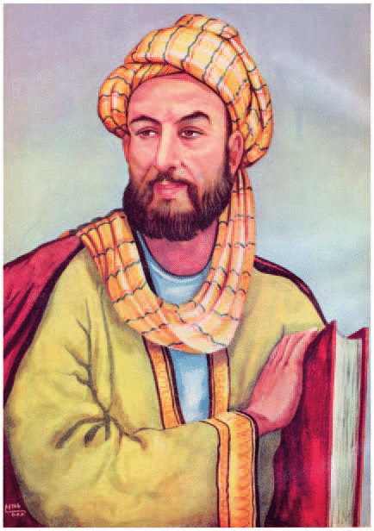  Tom Daley (PSHE)   | Wangari Maathai (Sc)  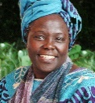  Boudicca (H)  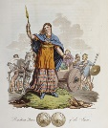  Emperor Claudius (H)  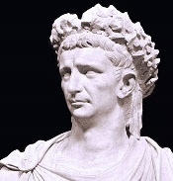 | Roger Bacon (Sc)  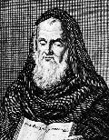  Malala Yousafzai (PSHE) | Eugenie Clark (Sc)  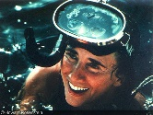
Willow (Cycle 2) | Mary Anning (Sc)  Sir Edmund Hillary and Tensing Norgay (H)  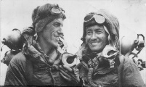  Dalai Lama (PSHE)  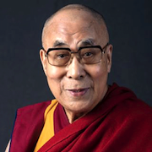  Tim Berners-Lee (C)  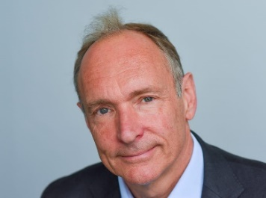 | Alexander Von Humboldt (Sc)  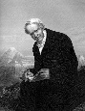  Vasco Da Gama (G)  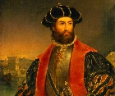  Jadav Payeng (G)  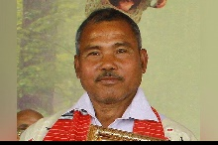  Ada Lovelace (C) | Joseph Banks (Sc)  Henry Brown (PHSE)  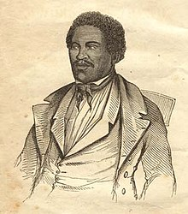  Greta Thunberg (PSHE) | William Gilbert (Sc)  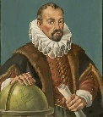  Tom Daley (PSHE) | Martha Coston (Sc)  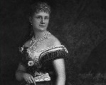  Matthew Flinders (G)  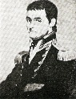  Jules Verne (DT)  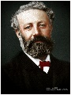 | Stephanie Kevlar (Sc)    King Aethelbert (H)  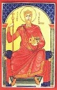  John Williams (M)  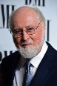
Fig (Cycle 1) | Georges Melies (H & DT)  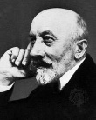  James Clerk Maxwell (Sc)  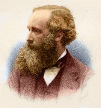  Steve Jobs (C)   | Sir Isaac Newton (Sc)  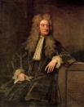  Joseph Ruston (H)  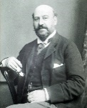  Thomas Edison (Sc) 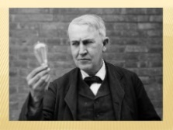 | Marie Tharp (Sc)  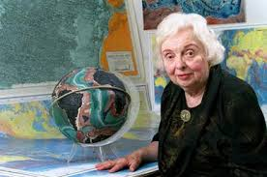  Yuval Zommer (A)  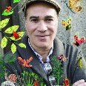  Kamala Harris (PSHE)  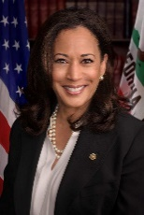  Amanda Gorman (PSHE)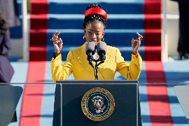 | Joan Procter (Sc)  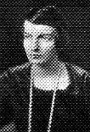  Daudi Tinga Tinga (A)  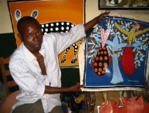  Harriet Tubman (PSHE)  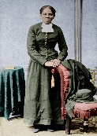 | Katherine Johnson (Sc)  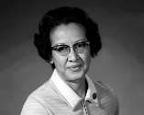  Howard Carter (H)  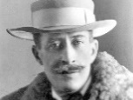  Tutankhamun (H)  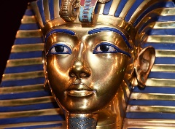 | Vera Rubin (Sc)  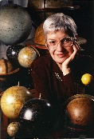  Stephen Hawking (Sc)  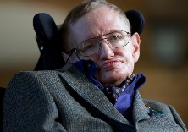  Tegla Laroupe (PSHE)  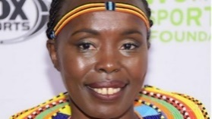
Fig (Cycle 2) | Leonardo da Vinci (Sc)  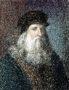  King John (H)  Richard the Lionheart (H)  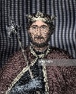 | Charles Dickens (H)  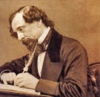  Lewis H Latimer (Sc)  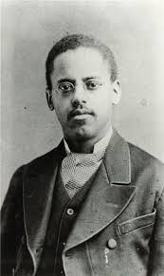  Queen Victoria (H)  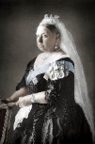  Dr Livingstone (PSHE)  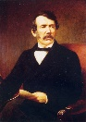 | Anoushka Shankar (M)  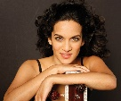  Les Paul (M/Sc/G)  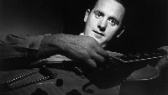  Grace Hopper (C)  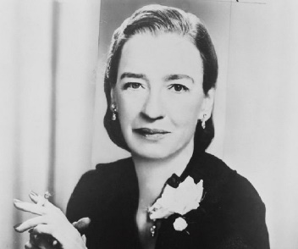 | Jane Goodall (Sc)  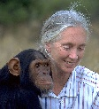  Django Reinhardt (M)  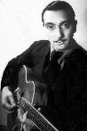 | Ruth Benerito (Sc)  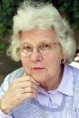  Gandhi (PSHE)  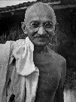  Rigoberta Menchu (PSHE)  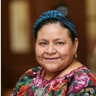 | Katherine Johnson (Sc)  Martin Luther King (PSHE)  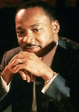  Rosa Parks (PSHE)  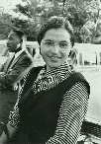
Clover (Cycle 1) | Charles Darwin (Sc)  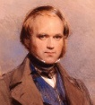  Queen Victoria (H)  Audubon (Sc)  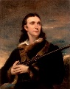  Charles Babbage (C)  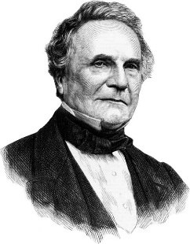 | Shaun Tan (A)  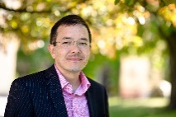  Carl Linneus (Sc)  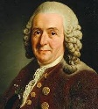  Jackie Morris (A)  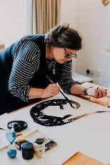 | Katherine Burr Blodgett (Sc)  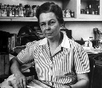  Dame Vera Lynn (M)  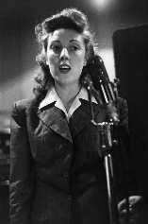 | Alan Turing (Sc)  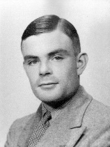 | Francoisse Barre-Sinoussie (Sc)  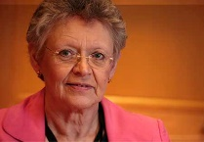 | Cheng Tang (H)  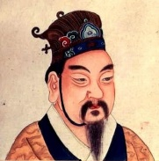  Lady Fu Hao (H)  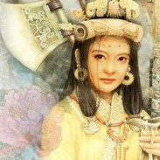  Zheng Zhenxiang (H)  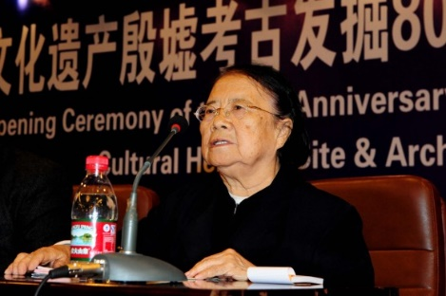
Clover (Cycle 2) | Rosalind Franklin (Sc)  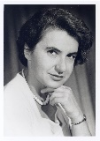  Charles Darwin (Sc) | Jackie Morris (A)  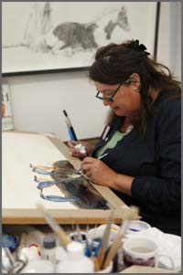  Alfred Russell Wallace (Sc)  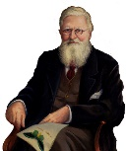  Carl Linneus (Sc)  Alan Turing (C) | Sir Isaac Newton (Sc)  Edward the Confessor (H)  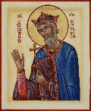 | Marie Van Brittan Brown (Sc)  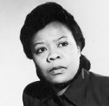  Sweyn Forkbeard (H)  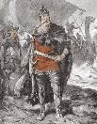  Alhazen (DT/S)  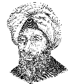 | Thomas Edison (Sc)  Lewis H Latimer (Sc) | Pythagoras (Sc)  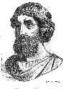  Thales (Sc)  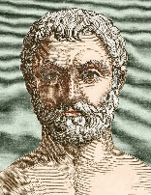  Wilma Rudolph (H)  