Synopsis  When Charlie's longed-for brother is born with a serious heart condition, Charlie's world is turned upside down. Upset and afraid, Charlie flees the hospital and makes for the ancient forest on the edge of town. There Charlie finds a boy floating face-down in the stream, injured, but alive. But when Charlie sets off back to the hospital to fetch help, it seems the forest has changed. It's become a place as strange and wild as the boy dressed in deerskins. For Charlie has unwittingly fled into the Stone Age, with no way to help the boy or return to the present day. Or is there? What follows is a wild, big-hearted adventure as Charlie and the Stone Age boy set out together to find what they have lost - their courage, their hope, their family and their way home. | The Wild Way Home  By  Sophie Kirtley  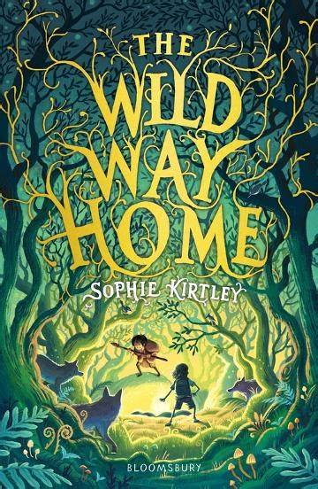 | Significant characters  Charlie  Lamont  Beaky  Harby  Mothga  Dara  Nero  Mum  Dad
Christian values  Courage – Charlie’s baby brother Dara is born with a heart condition. Charlie courageously deals with his emotions when hearing this news.  Friendship- From the very beginning of the story, strong friendships are introduced between Charlie, Lamont and Beaky. They enjoy each others company and an element of trust is clear. Further in the story, Charlie makes friends with Harby (a Stone Age Boy) and together they look for Mothga (Harby’s baby sister). Even though they do not speak the same language they find a way to communicate, learn from each other and trust one another. | Location  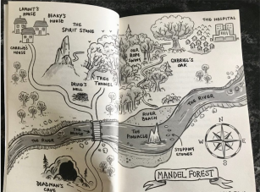  The story begins in modern day Mandel Forest where Charlie plays with Lamont and Beaky. During the story, Charlie realises he is still in Mandel Forest but things have changed! | Vocabulary  Hart – adult male deer  Concussion- brain injury caused by a blow to the head  Briar- prickly, scrambling shrubs  Lair- a place where a wild animal, especially a dangerous one, lives  Pinnacle- a high, pointed piece of rock  Stone Age – Paleolithic- early phase  Mesiolithic – middle phase  Neolithic- latter phase

