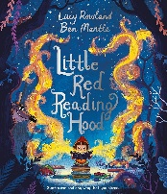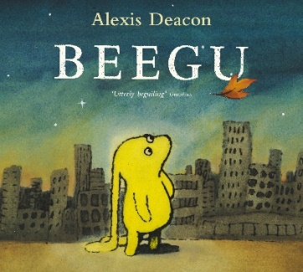**‘Journeys’**

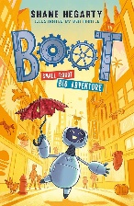Welcome back everyone, we have an exciting half term planned in Ivy Class. The books that are inspiring our learning this term are ‘Beegu’, ‘Boot’ ‘Wildsmith’ and ‘Little Red Riding Hood’. We will discover what it means to belong and why we belong. We will think about what makes us all special. This is intertwined with our Friendship Christian value. Our **PSHE** focus is Health & Wellbeing and Relationships.

We will show Beegu around our local area of Laughton and learn about the location of different countries in the UK in our **Geography** lessons using Atlases, world maps and globes. We will then take Beegu on a guided tour of the UK and name, locate and identify characteristics of the four countries and capital cities of the UK.

In **Maths** our topic will be number focusing on place value, addition and subtraction. In **English** we will be exploring poetry and writing our own poems. We will also be developing our descriptive writing and ensuring our writing is including all of those key components. In **Phonics and Spelling** we are using the Twinkl Phonics and Spelling scheme which we will be using daily.

We will explore everyday materials in **Science** and investigate their properties. Throughout the year we will be observing changes across the four seasons which will include local walks. In **Art** we will be developing our drawing skills and build up to creating a self-portrait using different shades and tones. This will also link to our **ICT** for this term which is learning how to use digital media.

In **RE** our topic is God and will be exploring the questions:

* What do Christians believe God is like?
* Who do Christians believe made the world?

Our **P.E**. lessons are on Wednesday morning. Please make sure your child comes dressed in their P.E. kit on this day. This will be led by Mr Johnson and Miss Fisher.

**Swimming for Year 2 is on Monday mornings beginning Monday 9th September**- Come to school in uniform with your swimming kit and towel in a named bag.

**Weekly Homework** - TT Rockstars, Numbots and Spelling Shed

Username and password information will be inside their reading record. Children will have their reading book changed weekly on a Friday.

We are always available to speak to at the beginning and end of the school day, or you can send us a message on Class Dojo.

**Mrs Newbury, Mrs Briscoe and Mrs Brown ☺**