after a short time
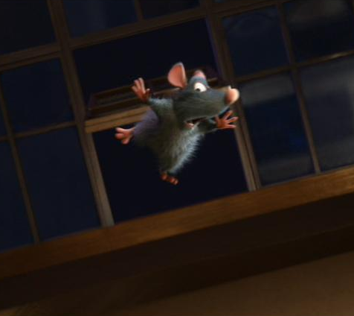
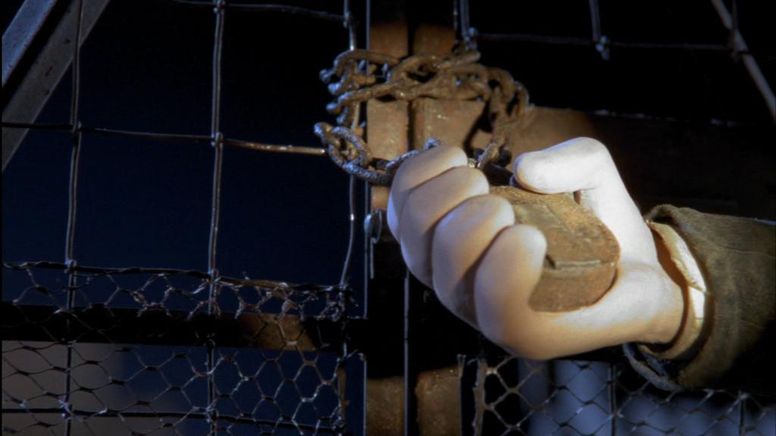
first of all
after that
subsequently
just then
finally
suddenly
a little later
next
after a long time
before very long
next
grasp
grip
clutch
seize
enfold
clasp
hold tight
hold close
cling to
squeeze
clench
embrace
grab
cleave to
Hold
meanwhile
snatch

