soft
noisy

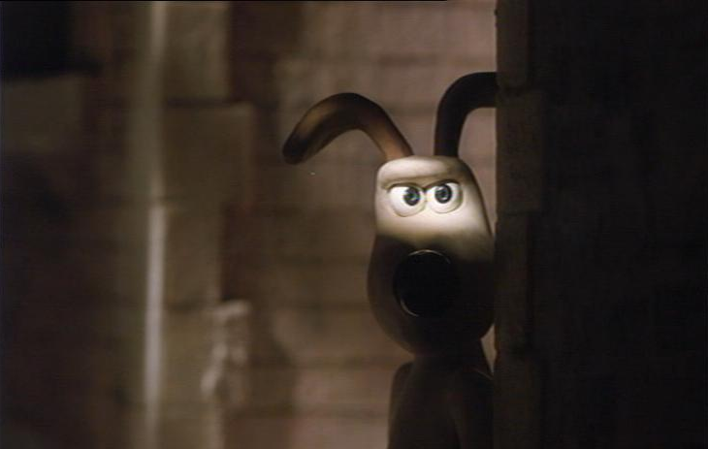

boisterous
thundering
booming
roaring
piercing
resounding
blaring
rowdy
whispered
faint
lowered
muted
stifled
suppressed
tumultuous
muffled
silent
hushed
vociferous
inaudible
vehement
indistinct
low-pitched
loud/quiet
excellent
world class
pleasant
great
pleasing
first-rate
first-class
outstanding
superior
splendid
superb
exceptional
fantastic
exemplary
exquisite
admirable
terrific
magnificent
marvellous
agreeable
brilliant
divine
acceptable
cracking
sterling
distinguished
good
deafening
obstreperous
tranquil

