little
mammoth
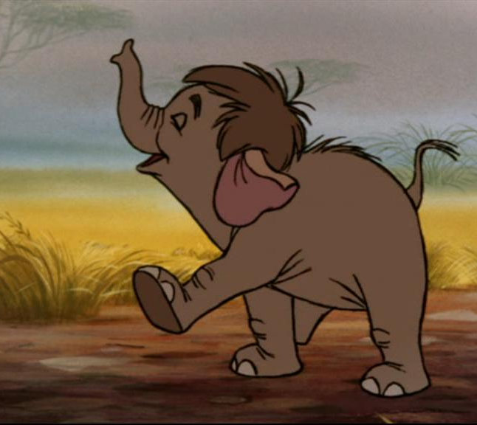
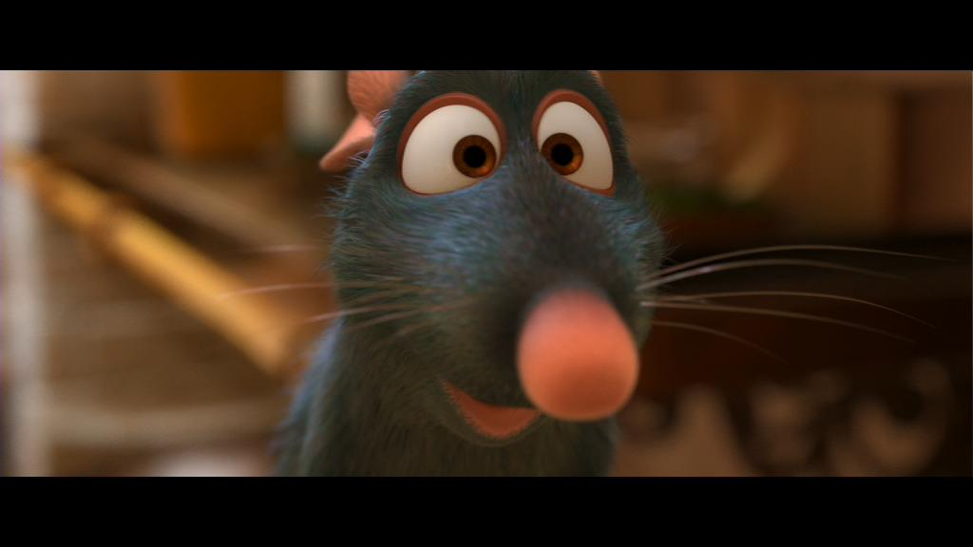
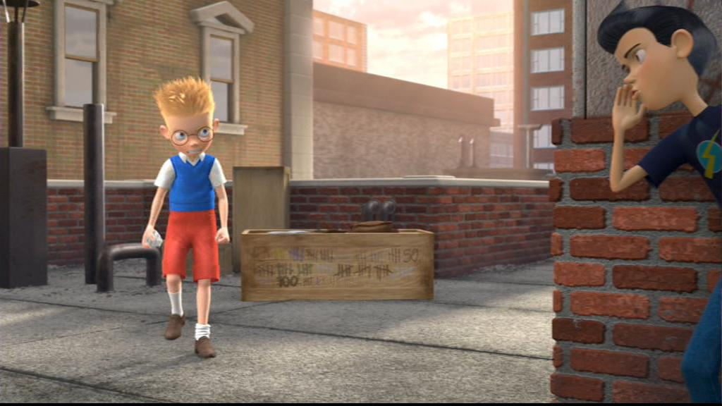
substantial
giant
large
huge
gigantic
immense
immeasurable
vast
diminutive
miniature
insignificant
minute
undersized
petite
titanic
compact
tiny
slight
thought
towering
measly
colossal
minuscule
pocket-sized
big/small
walked
stomped
danced
strolled
sauntered
scampered
dashed
meandered
scurried
sprinted
crept
plodded
darted
hopped
slithered
bustled
crawled
clambered
paced
scrambled
hobbled
tiptoed
skipped
skulked
marched
wandered
galloped
went
scuttled
enormous
sneaked
edged
ambled
darted
staggered

