
Blyton cum Laughton Church of England Primary School
‘I will instruct you and teach you in the way you should go; I will counsel you with my loving eye on you.’
Psalm 32:8

BcL READING-INSPIRED CURRICULUM: MATHEMATICS
INTENT, IMPLEMENTATION AND IMPACT

Subject Lead: Mrs Batey

INTENT:
Mathematics forms an important part of our everyday lives and as such, has an important role in our broad and balanced curriculum at Blyton Cum Laughton CE School. Mathematical fluency is an essential life skill for all learners and is a pre-requisite to being able to reason and solve problems mathematically. Our aim is to develop a positive culture of deep understanding, confidence and competence in maths that produces strong, secure learning. We want to ensure that children develop an enjoyment, wonder and enthusiasm for maths that will stay with them throughout their lives and empower them in future life. Where relevant, we will refer to influential mathematicians, past and present, through our ‘Extraordinary Lives’ element of our curriculum.

Our intent is to provide a curriculum that caters for the needs of all individuals. Through the use of White Rose Mathematics, we incorporate sustained levels of challenge through varied and high-quality lessons with a focus on fluency, reasoning and problem solving. We encourage resilience and acceptance that mistakes are a necessary step in learning. Our ambition is for all children to become fluent mathematicians, who can confidently recall and apply mathematical knowledge and demonstrate conceptual understanding. We aim for all our children to be proficient users of mathematical language, which will support them in their mathematical reasoning in different contexts. Our aim is for children to become competent problem solvers, through applying their mathematical knowledge to wide range of problems, in maths lessons, other subjects and in ‘real life’.

Using our school Christian Values, we will:

Friendship - develop the communication skills to work together mathematically
Courage - meet new mathematical challenges with positivity
Hope - persevere and try different ways to reach an answer
Thankfulness - feel confident in our skills and knowledge
Compassion - use our communication and mathematical skills to support others
Trust - have faith in the knowledge and skills we have already to meet new mathematical challenges

IMPLEMENTATION:
As a school, we recognise that the key to unlocking the potential in our children is through the development of basic mathematical skills and the understanding of mathematical concepts. As such, we place great emphasis on the use of concrete resources and pictorial representations at all ages, to enable children to fully understand the concepts and principals, when presented with abstract calculations and questions. Our maths curriculum is progressive; at KS2 it is designed to develop competencies to equip pupils for KS3 where they will build on KS2, make connections and solve increasingly sophisticated problems.

Our curriculum uses:
Visualisers – the CPA (Concrete, Pictorial, Abstract) approach is used to help pupils understand mathematics and to make connections between different representations.
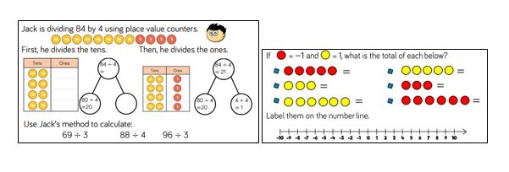

Describers –great emphasis is placed on mathematical language and questioning so pupils can discuss the mathematics they are doing, and so support them to take ideas further.
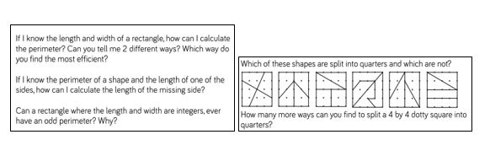
Experimenters – as well as being fluent mathematicians, we want pupils to love and learn more about mathematics.
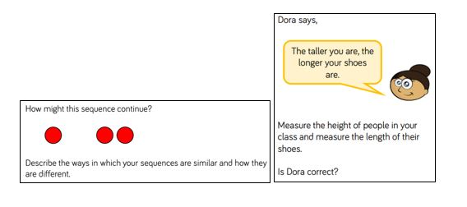

We use the White Rose Mathematics small, cumulative steps approach in our daily maths lessons, ensuring that our pupils are able to recognise the connections between the units of learning. Our maths curriculum may also be supported through the implementation of other relevant resources; for example, for those pupils who may require further challenges to deepen and challenge understanding, or for those who require additional support. Rapid Recall boards are also used daily to reinforce key mathematical skills. Times tables also play an important part in our maths learning, with children developing their fluency in rapid recall of tables up to 12 x 12 by the end of year 4. For this we use Times Table Rock Stars which generates enthusiastic learners determined to develop and improve their skills.

Teachers carry out formative assessment within each session and feedback is given to children verbally, through self/peer assessment and through whole class marking. These assessments are then used to identify those needing further challenge or additional support within the next session. At the end of each term, we will make summative assessments using PUMA (Progress in Understanding Mathematics Assessment) that help to identify areas of progress and areas for further development for each individual pupil, indicating where gaps need to be closed. Where applicable, SEND pupils may have specific maths targets on their termly Pupil Passports.

IMPACT:
By the end of KS2, transitioning to secondary school, a Blyton Cum Laughton mathematician will have developed a range of efficient and accurate skills that can be used to calculate effectively and will enable children to identify when answers do not make mathematical sense. Children will be able to apply these calculation skills and understanding of other areas to become confident and resilient problem-solvers with the ability to reason and articulate their ideas mathematically using appropriate language. They will have recognised where links can be made across different elements of the maths curriculum, and seen how skills can be applied in different contexts. They will also have accessed all aspects of the National Curriculum.

