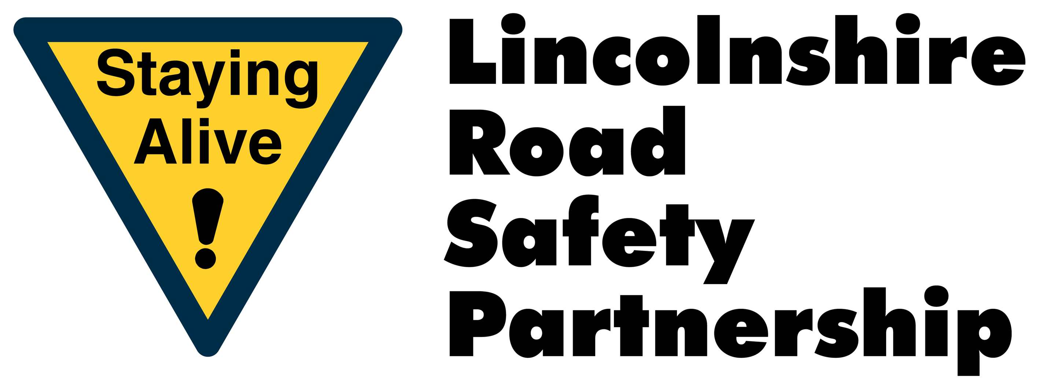

School Crossing Patrol Vacancy

Helping children cross the road is an important job. You will need to be traffic aware, have a sense of responsibility and the ability to work alone, outside on the highway and in all weathers.

Location: High Street. Blyton

Reference: 20022231

Morning Start Time: 8.25

Morning Finish Time: 9.00

Afternoon Start Time: 15.10

Afternoon Finish Time: 15.55

Total Hours: 6 hours 40minutes

Hourly Rate: £10.98

Monday – Friday School Term Time Only

For further information please contact :
Pam Street (Road Safety Officer) - pam.street@lincolnshire.gov.uk

