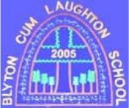

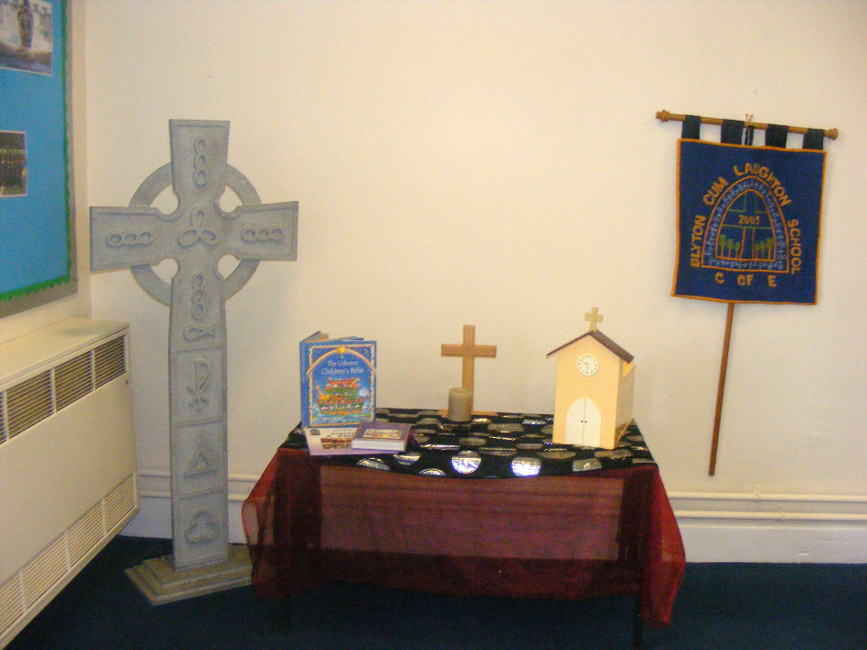

Blyton cum Laughton

Church of England Primary School

RELIGIOUS EDUCATION POLICY

Psalm 32:8 – “I will instruct you and teach you in the way you should go; I will counsel you with my loving eye on you.”

|  |  |
| --- | --- |
|  |  |
| Monitoring responsibility | K Duke (Headteacher) |
| Date ratified | Oct 2024 |
| Head teacher’s signature | cid:image001.png@01D71100.837F28E0 |
| Chair of Governor’s signature |  |
| Review date | Oct 2026 |

*This policy is underpinned by the Christian ethos and values of the school. At Blyton cum Laughton Church of England Primary School we seek to support every individual to achieve their best and recognise that each one of us has our own talents which should be nurtured. The Christian values are vibrant strands woven within the very fabric of this school's culture.*

**Introduction**

This policy is set in the broader context of our school vision in the context of an enabling culture founded on our Christian values.It reflects our commitment to ensure the spiritual, moral, social, cultural and intellectual development of our pupils and helps them to gain a greater understanding of themselves and a more sympathetic awareness of the needs and beliefs of others. This enables pupils to be better equipped to cope with the responsibilities and experiences of adult life.

**Our Vision**

As an inclusive and welcoming church school, we strive to nurture and value all members of our school community. Our inspiring and ambitious learning environment and curriculum enables all pupils and adults to be happy, to care and to achieve.

**Psalm 32:8: ‘I will instruct you in the way you should go; I will counsel you with my loving eye.’ to:**

•  **be a figure of faith, following in the footsteps of Christ through communication, prayer and friendship**

•  **take the lead to be the best trusted version of ourselves**

•  **be courageous when faced with or exploring challenge and adversity**

•  **be thankful for our innovative and imaginative problem solving**

•  **be compassionate and caring global citizens**

•  **provide hope through our creations**

Our school vision is lived through our aims and values, enriching lives and creating a compassionate community of ambitious learners.

**Our BcL Aims:**

**At BcL, we aim to encourage everyone in our school community:**

•  **to be respectful, tolerant and walk in the light of Christ**

•  **to take ownership of their actions, excel as individuals and have a positive impact as citizens in the 21st century**

•  **to explore and be inquisitive, showing a thirst for learning**

•  **to persevere, be resilient learners, to find solutions and have high aspirations for the future**

•  **to show compassion, empathy and care for others**

•  **to be creative**

**Our BcL Christian Values:**

|  |  |  |
| --- | --- | --- |
| **Friendship**  ***'Make your light shine so that others will see the good that you do and will praise your Father in heaven.'***  ***Matthew 5:16*** | **Trust**  ***'I will instruct you and teach you in the way you should go; I will counsel you with my loving eye.'***  **Psalm 32:8** | **Courage**  ***'Be strong and courageous for the Lord will be with you wherever you go.'***  **Joshua 1:9** |
| **Thankfulness**  ***'He has made everything beautiful in his time.'***  **Ecclesiastes 3:11** | **Compassion**  *'****Be kind and compassionate to one another, forgiving each other, just as in Christ God forgave you.'***  **Ephesians 4:32** | **Hope**  ***'In the beginning God created the heavens and the earth.'***  **Genesis 1:1** |

**Policy and Practice**

This curriculum policy reflects our agreed principles and practice to ensure all learners have equal access to a broad, balanced and ambitious curriculum**.**

**BcL Curriculum Statement**

Through our Christian Faith at Blyton cum Laughton Church of England Primary School, we acknowledge our responsibility to all, to enrich lives and show love and respect within our school family. We offer a rich and vibrant **Reading-Inspired Curriculum**, which is ambitious, meaningful and memorable for all learners. Threaded throughout are our six Christian Values - **Friendship**, **Courage**, **Hope**, **Thankfulness**, **Compassion** and **Trust**. Together with our key drivers, the **BcL Inspirational Themes** of **Diversity**, **Exploration**, **Creativity**, **Innovation and Progress**, **Care and Protection** and **Leadership**, we celebrate diversity and utilise skills, knowledge and the cultural wealth of the community, enabling our children to flourish spiritually, socially, emotionally, morally and culturally. To support these themes we have identified key figures from history to the present day who children will learn about through each year of their curriculum. We call this the **BcL** **Extraordinary Lives**. These **Extraordinary Lives** are split into six categories: **Figures of Faith**, **Leaders**, **Explorers**, **Innovators, Carers** and **Creators. They** each link closely to our six **BcL Christian Values**

**BcL Curriculum Intent**

The BcL Reading-Inspired Curriculum, based on the Early Years Foundation Stage Curriculum and the Primary National Curriculum, works alongside the Lincolnshire Agreed Syllabus and Understanding Christianity. The curriculum embraces high quality texts as the foundation to provide inspiration for learning and nurture aspiration in our children to become **Figures of Faith**, **Explorers**, **Creators**, **Innovators**, **Carers** and **Leaders**: the focus of our **BcL Extraordinary Lives**. Our reading and wide-range of enrichment experiences promote confident, self-motivated pupils eager for lifelong learning, preparing them for their next step in their education and developing an understanding of the world in which they live.

Our curriculum is underpinned by the teaching of basic skills, knowledge, themes and values, however reading is pivotal at Blyton cum Laughton including through the teaching of religious education.

The school’s starting points are the two Attainment Targets in the county agreed syllabus:

1. To produce pupils who are religiously literate and able to hold balanced and informed conversation about religion and belief

2. Pupils should develop key skills in RE in order to enhance learning and this should be evident across key stages

**RE at BcL:**

* develops pupils’ knowledge and understanding of Christianity as well as other principal religions and world views
* focuses on concepts as well as content, within the context of enquiry based learning
* explores authentic religious material, e.g. sacred texts
* reflects diversity in terms of the changing religious landscape of the UK (see 2011 census below) so that they are prepared for life in modern Britain
* engages and challenges pupils
* reflect pupils’ own experiences and provide a safe space for discussion
* presents religious belief as a real, lived phenomenon, not something exotic or belonging to the past
* takes into account the increase in the number of people with non-religious beliefs and identities
* provides opportunities for personal reflection and spiritual development
* helps to prepare pupils for adult life, enabling them to develop respect and sensitivity for others

**RE skills:**

Pupils develop key skills in RE in order to enhance learning and this should be evident across key stages:

1. Investigation and enquiry: asking relevant and increasingly deep questions; using a range of sources and evidence, including sacred texts; identifying and talking about key concepts.

2. Critical thinking and reflection: analysing information to form a judgement; reflecting on beliefs and practices, ultimate questions and experiences.

3. Empathy: considering the thoughts, feelings, experiences, attitudes, beliefs and values of others; seeing the world through the eyes of others.

4. Interpretation: interpreting religious language and the meaning of sacred texts; drawing meaning from, for example, artefacts and symbols.

5. Analysis: distinguishing between opinion, belief and fact; distinguishing between the features of different religions. 6. Evaluation: enquiring into religious issues and drawing conclusions with reference to experience, reason, evidence and dialogue.

**BcL RE Curriculum Implementation**

In RE, we will implement our curriculum by providing an ambitious, broad and balanced approach which will support each one of us to become successful learners. We do this through:

* Providing Religious Education in accordance with the Locally Agreed Syllabus or Lincolnshire 2023 to ensure that every pupil receives meaningful RE with challenge
* Ensuring RE fulfils the statutory requirement of curriculum time, with the balance of faith being consistent to RE entitlement.
* Ensuring children will meet each unit at least once based on a two year rolling programme in each phase.
* Encouraging Foundation Stage children to reflect upon and discuss their own experiences and begin to relate these to themes in stories and religious teachings.
* The in-depth study of Christianity and Islam in Key Stage 1 and Christianity, Islam and Hinduism at Key Stage 2 as well as providing opportunities for children to encounter other world religions and views.
* Teaching subject specific knowledge, vocabulary, skills and concepts to ensure children master the content of RE through substantive and disciplinary knowledge.
* High quality teaching and learning, which will include the use of picture books, enquiry, art, drama, debate, multisensory activities, visits/visitors and IT to ensure accessibility to all.
* Maximising cross-curricular links: Due to the broad nature of Religious Education, it forms natural links with a range of other curriculum areas e.g. English, drama, music, art, history, geography and PHSE. Religious Education work reinforces cross- curricular elements e.g.: skills such as observing, questioning, discussing, evaluating and reflection; gender, citizenship and diversity.
* Teaching religion and belief from a local, national and global perspective to remove stereotypes and encourage children to understand religion and belief as an interpretation which may differ from person to person, culture to culture and between denominations.
* Utilising links with the community including regular visits to local churches in the two villages.

**Curriculum time for RE**

The RE curriculum is usually taught weekly but teachers have the flexibility to use blocked time or plan RE days/weeks.

At BcL, we follow the Dearing Review (1996) guidance:

KS1: 36 hours per year

KS2: 45 hours per year

**Enrichment: Educational Visits and Visitors, local context using community links and partnerships**

R.E. learning is enriched through:

* Visits to places of worship and other places of significance to groups of believers
* Visitors into school to share their beliefs, experiences and provide and opportunity for children to ask questions

**Assessment, Recording and Reporting**

Evidence of substantive, disciplinary and personal knowledge (as detailed in ‘Assessing progress in RE’ guidance document from the Lincoln Diocese Education Board-2021) is gathered from written work, artwork, observations, pupils’ reflections, oral discussion, questioning and evaluation and a judgement made at the end of the year. Report cards are sent home at the end of the year to reflect if a child has met the Expected Standard and the effort they have contributed within the subject. The Foundation stage children are assessed through the specific areas of the early learning goals.

**Monitoring, Evaluation, Impact and Assurance:**

To ensure effective and rigorous teaching of R.E. across school, the subject leader monitors standards in the subject using the progression in knowledge, concepts and skills document, as well as their own subject and pedagogical knowledge. This helps the subject leader to corroborate teacher judgements and provide support, where necessary, to both pupils and staff. A range of monitoring activities are undertaken at various points throughout the year, which may include book and planning scrutiny, lesson observations and pupil interviews. Monitoring is evaluated and clear actions are identified. Subject Leaders assure Senior Leaders and Governors through verbal reporting.

**Withdrawal from RE:**

We acknowledge the right of parents/guardians to withdraw their children from RE lessons and of teachers to withdraw from teaching the subject. We acknowledge that parents/guardians/teachers do not need to provide a reason why they wish to withdraw from the subject. Should a parent/guardian wish to withdraw their child from RE lessons or a teacher wish to refuse to teach RE, we require that written notice be sent to the RE Subject Leader/head teacher/school governors.

Should a parent/guardian request that their child be withdrawn from RE, we will endeavour to communicate clearly the place of RE within a broad and balanced curriculum to ensure that they are in possession of all the necessary information before confirming their decision. However, we will not attempt to persuade them to alter their decision. If a pupil is withdrawn from RE lessons, the school is required to provide supervision, but should not incur any additional cost in so doing. Any queries regarding withdrawal from RE should be directed to the RE Subject Leader in the first instance, and thereafter to the head teacher.

**Monitoring and Evaluation**

The Headteacher and RE/Collective Worship Lead review this policy every two years.