

'**Make your light shine so that others will see the good that you do and will praise your Father in heaven.'**

**Matthew 5:16**

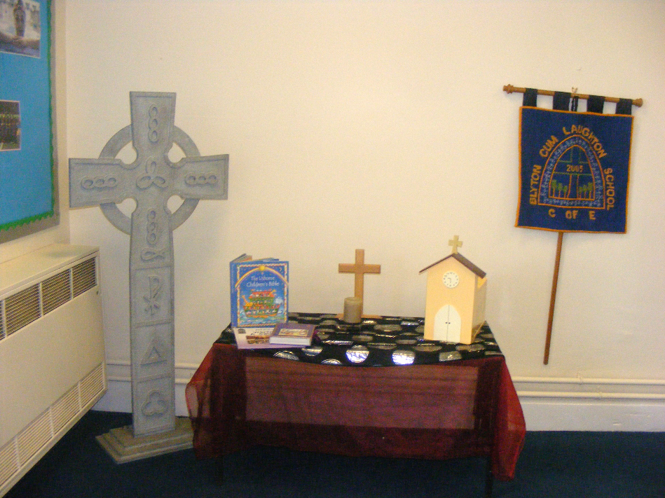

|  |  |
| --- | --- |
|  |  |
| Monitoring responsibility | K Duke (Headteacher) |
| Date ratified | December 2022 |
| Headteacher’s signature |  |
| Chair of Governor’s signature |  |
| Date of review | December 2025 |

Blyton cum Laughton Church of England Primary School

Accessibility Policy

Supporting your school’s success.

Providing you with proactive and tailored HR, Payroll & Pensions, Safeguarding and Health & Safety support.

We listen. We support. You achieve.

Last revised: September 2020

**Contents Page**

|  |  |
| --- | --- |
| Planning Duty  Aims and Objectives  Procedures  Physical Environment  Curriculum  Information  Current Activities  Review and implementation  Accessibility 3 Point Action Plan | 3  3  4  4  4  4  4  5  6 |

# **Blyton cum Laughton Church of England Primary School ’Planning Duty’**

This Accessibility Plan is drawn up in compliance with current legislation and requirements as specified in relation to Disability, of the Equality Act 2010. The Governing Body are accountable for ensuring the implementation, review and reporting of progress of the Accessibility Plan over a prescribed period. The Equality Act 2010 replaced all existing equality legislation, including the Disability Discrimination Act. The effect of the law is the same as in the past, meaning that “schools cannot unlawfully discriminate against pupils because of sex, race, disability, religion or belief and sexual orientation”. According to the Equality Act 2010 a person has a disability if:

1. He or she has a physical or mental impairment, and

(b) The impairment has a substantial and long-term adverse effect on his or her ability to carry out normal day-to-day activities.

At Blyton cum Laughton CE Primary School, we ensure we follow the Equality Act 2010 and ensure protection against discrimination, harassment and victimization (direct or indirect) for everyone under the nine characteristics: age, disability, gender reassignment, race, religion or belief, sex, sexual orientation, marriage and civil partnership, and pregnancy and maternity. This includes Gender Reassignment (also known as Transgender).

The Accessibility Plan will be published on the school website.

Definition of special educational needs:

In this policy, ‘special educational needs’ refers to a learning difficulty that requires special educational provision.

The SEND Code of Practice 0 to 25 Years (DfE, 2014) says children have a learning difficulty or disability if they:

• have significantly greater difficulty in learning than the majority of children of the same age; or

• have a disability which prevents or hinders them from making use of facilities of a kind generally provided for children of the same age in mainstream schools or post-16 institutions; and

• are under compulsory school age and are likely to fall within either of the definitions above when they reach compulsory school age or would do so if special educational provision was not made for them. Children must not be regarded as having a learning difficulty solely because the language or form of language of their home is different from the language in which they will be taught.

**Aims and Objectives**

**Our Aims are to:**

* increase access to the curriculum for pupils with a disability
* improve and maintain access to the physical environment and take advantage of

education associated services

* improve the delivery of written information to pupils

Our objectives are detailed in the Action Plan below. However, this Accessibility Plan is not a standalone document, but should be considered alongside the following school policy documents:

* Equal Opportunities
* Special Educational Needs & Disabilities (SEND) Policy
* Safeguarding Policy
* Health & Safety Policy
* Staff related policies, and risk assessments

**Procedures**

This plan will also be used to advise and inform future planning documents and policies.

We aim to ask about medical and special educational needs, as well as any concerns parents may have in early communication with new parents and carers. For parents and carers of children already at the school, we collect information on disability on a regular basis through discussions with parents and outside agencies.

**Physical Environment**

The physical environment at both sites is fully accessible for all uses and have good wheelchair access both indoors and outdoors. The Laughton building is on one level and so in general does not cause any particular difficulties. Blyton has an upper level with lift access if required. We have ramps in place at most of the exit doors in areas where access is not on the same level, to ensure that wheelchair users can exit the building safely. All corridors are wide and there are no issues with being able to move around school safety for any person in a wheel chair. We have rails where there are steps and slopes to access all aspects of the school grounds.

Both sites have fully accessible disabled toileting facilities and in some child toilet areas, cubicles have been converted with handrails and grips. Doors where required have been installed to open outwards to ease access.

Any new or existing persons attending school sites that may have a disability temporary or permanent are risk assessed to ensure we are providing safe accessible premises.

**Curriculum**

With the support of parents and outside agencies, areas of the curriculum, for example PE, are adapted to the needs of children in school with physical impairments. The school is aware that other issues may affect the participation of disabled pupils, for example: bullying, peer relationships, policies on the administration of medicines, the provision of personal care, the presence or lack of role models or images of disabled people, and follow school policies and procedures to ensure that these are all dealt with effectively. Where necessary, pupils will have the necessary equipment in classrooms provided to enable them to be a part of the class and physically access the curriculum. Equipment may include; writing slopes, different chairs/seats, use of laptops or moving desks to more accessible locations etc.

**Information**

Different forms of communication are made available to enable any disabled pupils to express their views and to hear the views of others. Access to information is planned, and can be accessed in different ways on request, should this be needed.

**Current Activities**

At Blyton cum Laughton CE Primary School we have close working relationships with different nurseries and pre-schools and ensure that transition arrangements are organised throughout the summer term before the child starts school. This may include multi-agency meetings with parents/ professionals and/or visiting the child in their current settings. The school SEND Policy ensures that staff identify, assess and arrange suitable provision for pupils with special educational needs and/or disability, working with outside agencies, Health Professionals and Educational Psychology Services. The SENCo and Headteacher manage the Statutory Assessment process, ensuring additional resources, including staffing, are allocated where appropriate through additional high needs top-up funding. We have strong systems in place to ensure that we meet the needs of all of our pupils including Provision Mapping, which identifies children and interventions. These are produced and reviewed termly alongside whole school tracking systems.

All staff work together as a team to ensure strategies for improving pupils’ behaviour and access to learning is effective. Our learning mentor supports in classes and during unstructured times and is well-trained in supporting a range of needs.

At Blyton cum Laughton CE Primary School, we work closely with specialist services including: **Local Authority Provision delivered in school**

* STT (Specialist Teaching Team)
* WTT (Working Together Team)
* Educational Psychology Service
* Sensory Support Education Team (SEST) for children with visual or hearing needs
* Parent Partnership Service
* SALT (Speech and Language Therapy)
* The Virtual School for LAC (Looked After Children)

Please see the Local Offer and SEND Information Report for further information about the facilities and support currently on offer at the school, which can be found on the school website.

**Review and Implementation**

The Accessibility Policy is reviewed annually by the Governing Body and Headteacher. In addition, the Accessibility Plan will be reviewed three yearly by all relevant parties.

**Blyton cum Laughton CE Primary School Accessibility Action Plan**

**Blyton cum Laughton CE Primary School works towards three specific aims to enable accessible learning and education across our schools.**

Aim 1 - To increase the extent to which any disabled pupils can participate in the school curriculum

Aim 2 - To improve the physical environment of the school

Aim 3 - To improve the delivery of information to disabled pupils and parents

|  |  |  |  |  |
| --- | --- | --- | --- | --- |
| **Aim 1 Targets - To increase the extent to which any disabled pupils can participate in the school curriculum** | | | | |
| **Target** | **Strategy** | **Timescale** | **Responsibility** | **Success Criteria** |
| To comply with the Equality Act 2010. | Review all statutory policies to ensure that they reflect inclusive practice and procedure | On-going | Headteacher  SLT  All subject leaders  Governors | All policies clearly reflect inclusive practice and procedure |
| To identify pupils who may need additional provision to ensure smooth transition. | * Liaise with pre-school providers to review potential intake for September 2023-2024-2025 * Liaise with SENCo’s to ensure clear transfer of records/information * Arrange multi-agency meetings where necessary to ensure the provision is suitable * Observe the child in their previous school setting prior to attending BcL * Any changes in pupil’s needs identified termly and SEND pupil passports to reflect any needs identified   Meeting arranged with parents – information sharing/needs of the child- at least termly | During end of year transition and continually monitor | Headteacher  SENCo  EYFS Teacher | Procedures,  resources/equipment and strategies in place  Parents are kept informed of provision and consulted |
| To ensure all staff are fully aware of the needs of all pupils who have an EHCP/SEND  support | * Transition meetings in the summer term * Transfer of records / meetings with teachers and relevant staff & * SEND folders up-dated and to include all relevant documents/info. shared * Create and up-date provision maps showing the overview for each year group and individual pupil’s need | Transition meetings at the end of year On-going meetings  SENCo | SENCo  All staff | * All staff are clear about their responsibilities in meeting pupil’s needs   Targets identified and on provision maps and/or SEND Profiles where needed |
| To ensure parents are fully involved in the SEND profiles  process and understand how to support their child at home. To ensure that pupils are involved in  their SENDtargets and  EHCP meetings (where appropriate). | * SEND Targets are reviewed 3x a year * Discussion on targets and parent views considered * Targets to be clearly identified on pupil passports for parents to work on * Staff to complete parent meeting notes – proforma in SEND folders * Parents to complete a questionnaire – analyse/review and take action steps where needed | 1 x termly minimum with class teacher  Parents can request SENCo to arrange drop in sessions every week | Class teacher  SENCo  Parents | * SEND profiles and pupil passports reviewed with parents and new targets shared • Parents understand targets and know how to support their child with at least one of the targets * All parents aware of the SEN needs of their child. * Evidence/tracking of meetings held with parents completed by teachers and used to monitor parent views and feedback on SEND Profiles. |
| To review out of hours provision and  develop/ensure  accessibility for all pupils. | * Monitor club members * Meet with club leaders * Ensure accessibility and improve where possible | On-going | HT  Club Leaders  SENCo | All out of hours activities are organised to be accessible to all pupils in school. |
| Pupil Voice | * Children are given opportunities to share their concerns, their views and their ideas. * Adaptations are made as needed. | On-going | SLT  The children | All children are heard and ideas and views are acted upon. |
| **Aim 2 Targets - To improve the physical environment of the school** | | | | |
| **Target** | **Strategy** | **Timescale** | **Responsibility** | **Success Criteria** |
| To continue to maintain the physical environment of the school in order to maintain accessibility for all pupils | **Indoor**   * Identify needs of new in-take and make reasonable adjustments to the physical environment * Assess needs of pupil and plan for smooth transition * Plan classrooms accordingly * Environment monitoring to take place on a regular basis. * Ensure environments meet the needs of the children by being stimulating but not overly through learning walks, drop-in sessions, mini observations etc. * Needs of the child to be carefully thought through   and classrooms adapted accordingly   * Seek views of children * Involve STePs Teams to support with transition and any specialist equipment * Maintain good working order of all disabled toilets and facilities   **Outdoor**   * Maintain good up-keep of all areas to allow easy access * Pupil questionnaire - Seek pupil views through Junior Leadership Team on improving play areas   Fire Routes – continue to follow procedures to ensure all disabled pupils and staff are aware of safe routes | Ongoing | Headteacher  Governors  SLT  SENCo  Caretaker/cleaner  All staff | The environment is suitable for disabled children entering school  Classroom environment is accessible and meeting the needs of pupils wherever possible |
| To be aware of the access needs of disabled children, staff, governoes and parents/ carers | * Ensure the school staff & governors are aware of access issues (‘access’ meaning ‘access to’ and ‘access from’) * Create access plans for individual disabled children as part of the SEND (Special Educational Needs and Disabilities) process * Ensure staff and governors can access areas of school used meetings * Annual reminder to parents and carers through newsletter to let us know if they have problems with access to areas of school * Ensure a PEEP (Personal Emergency Evacuation Plan) is prepared and reviewed if someone at school (pupil or adult) becomes physically impaired * Communication in print around school to help children’s understanding and visual recognition. | As Required | All Staff | * SEND objectives are in place for disabled pupils, and all staff are aware of pupils’ needs. * All staff & governors are confident that their needs are met. * Continuously monitored to ensure any new needs arising are met. * Parents have full access to all areas of school * PEEPs are prepared and reviewed as individual needs change |
| Maintain safety for visually impaired people | * Check if any children have a visual impairment resulting in yellow paint being needed on step edges and other edges * Check exterior lighting is working on a regular basis * Put black/ yellow hazard tape on poles at end of play equipment to help visually impaired children, if appropriate * Check flashing beacons that signal fire alarm activation regularly | Ongoing and annually, and as new children join the school throughout the year | Caretaker  Cleaner (Laughton) | * Visually impaired people feel safe in school grounds. Yellow edges and flashing beacons to be monitored as needed throughout the school year. |
| To ensure risk assessments are in place for key pupils | Up-date Risk Assessments for all pupils and share with staff  Monitor risk assessments and adapt if  needed to meet children’s needs | Annually and regularly | Headteacher  SENCo  All staff | * All staff aware of risks and pupils safely accessing the curriculum and school grounds   Risk Assessments are understood and followed up |
| To continue to develop the playground facilities for all children.    To ensure path ways are appropriate for wheelchair access. | * Look for funding opportunities * Involve the Junior Leadership Team * Regular checks and maintenance   Caretaker/cleaner to report any problems | Annually and regularly | Headteacher  Caretaker | * Inclusive child-friendly play areas.   Wheelchair access maintained around the school grounds |
| To ensure disabled parking is marked and available for disabled staff and disabled pupils only | * Caretaker and office staff to ensure correct use of the disabled parking space   Parents made aware of ‘rules’ for using the parking space | Ongoing | Caretaker | Parking fully accessible to meet the needs of pupils and parents |
|  |  |  |  |  |
| **Aim 3 Targets - To improve the delivery of information to disabled pupils and parents** | | | | |
| **Target** | **Strategy** | **Timescale** | **Responsibility** | **Success Criteria** |
| To up-date records to ensure school is fully aware of any disabled children/parents and their needs. | * Office staff aware of parent’s needs as notified and adapted material on request * The school will make itself aware of the services available for converting written information into alternative formats * Health Care Plans kept up-to-date – access to all and kept in the same place * Up-date Medical forms regularly – Up-date SEND forms in line with guidance | Annually | Headteacher  EYFS leads  Governors  SENCo  Office Teams  All staff | * All staff aware of the needs of the school * Records up-to-date   The school will be able to provide written information in different formats. |
| To ensure that the school environment offers further information to pupils and visitors. | * Photographs of all staff on display board with names * Classrooms labelled * Environmental print * Displays offer visual and written support/adapted where needed * Photographs/images for visual support on display * Monitored through learning walks |  | Office Staff  SLT  Teachers | Visual and written environment offers support and is consistent around the school |
| To continue to up-date and improve the school website to ensure information is fully accessible. | * Website redesigned/developed and improved over time * Checklist completed for all relevant information that needs to be on the website   Ensure parents are fully aware of the information available on the website |  | Headteacher | Website up-dated and all relevant information available and up-dated regularly  Friendly/easy to access website  Website used by parents |